# Motivation / Introduction:

*Motivation to write the thesis is determined be recent experience of unexpected phenomena that occurs in first high-power HVDC connected off-shore AC grid including wind power plant. In this power electronics dominated grid converters go into resonance between each other causing oscillations and instabilities in the internal network. These problems were not considered during planning period. Due to future plans of development of many off-shore wind farms, to avoid problems for future hardware, new methods of investigation and analysis should be developed or current ones should be extended.*

*Problem expansion:*

*In contrast to the continental European grid, there is not enough resistive loads present in the network dominated by converters, therefore the resonance is not damped well enough. Moreover, in the offshore WPP the collection grid from turbines consist of long cables which have much higher capacitance than regular overhead line. That switches the resonance frequencies to the lower levels where the other harmonics are present and can be amplified.*

*The purpose of the thesis is to analyse some available methods to detect harmonic resonances in off-shore wind farm grids and couple this study with stability analysis based on Nyquist stability criterion. Since the quality of theoretical study is significantly determined by the quality of utilized model and its elements, more accurate approach to model power converters’ impedance is used.*

# Theoretical introduction:

## Basics about harmonics

Generation of electricity in power system is usually at the frequency constant level of either 50Hz or 60Hz. Waveforms produced by rotating generator is practically sinusoidal and in this shape they should be delivered to every customer. However when sinusoidal waveform is applied to nonlinear load the resulting current is not purely sinusoidal. The current which is not perfectly sinusoidal leads to not perfectly sinusoidal voltage drop due to system impedance. Hence, the voltage distortion at load terminals is produced. The problem of presence of these distortions is not new in the power system. However the devices responsible for producing distorted waveforms and devices suffering from presence of the distortion have changed down the years.

A distorted, non-sinusoidal waveform can be expressed as a sum of so-called harmonic components. Harmonic component in power system is a perfectly sinusoidal waveform that has frequency equal to integer multiple of the fundamental frequency:

where is an integer (harmonic order) and is fundamental frequency (usually 50 Hz   
or 60 Hz). If is not an integer, such a waveform is called interharmonic component.

As aforementioned, any sinusoidal waveform can be expressed as sum of its harmonic components. Exemplary distorted current waveform for fundamental frequency and 3rd 5th and 7th harmonics is expressed as follows:

where are peak RMS values of fundamental component and harmonic components and are possible phase shifts of each harmonic.

Concerns for harmonics rises from power quality requirements. Power quality requirements are introduced to prevent from negative effects on electrical equipment which are sensitive to poor power quality. Poor power quality leads to damages of equipment, in other words, causes great money losses for industry. Moreover, certain types of equipment, if exposed to distorted waveforms, lead to further generation of harmonics. [Das]

## Harmonics Indices

There are two most common indices to describe content of the harmonics in the signal as one number: Total Harmonic Distortion (THD) and Total Demand Distortion (TDD). THD, which usually relates to voltage waveforms, is defined as RMS values () of the harmonics expressed relatively to fundamental components ():

where is the harmonic order and is maximum harmonic order to be considered. For most application, it is sufficient to consider harmonic order range up to 25th harmonic, but most standards recommend up to 50th [Das].

Since THD of current waveform can be misleading when load is low and can result in very high THD value, RMS values of harmonic currents can be related to rated or maximum current magnitude rather than to fundamental current (TDD):

This reflects distortion in more intuitive way since the electrical power supply systems are design to withstand rated (or maximum) values, while relation to fundamental components when load is far lower from rated value can give impression of much more significant distortion.

In the presented study these indices are also applied to the three-phase systems since for all cases the three-phase balanced system is considered. If the system is not balanced some averaging can be carried out [Das].

## Sources of distorted waveforms (harmonics)

As mentioned before the sources of harmonic distortions have changed down the years. In early power systems harmonic distortions were mainly caused by saturation of transformers industrial arc furnaces and other arc devices like electric welders. On the other hand, the main concern was the effect of those distortions on electric machines, telephones and on increased risk of failure from overvoltage. [Rosa]

Generally speaking, harmonics in power systems are produced due to many phenomena, for example, ferroresonance, magnetic saturation, subsunchronous resonance, and nonlinear and electrically switched loads. These days, harmonic emission from nonlinear loads dominates. [Das,ch1]

In transformers, harmonics appear as result of saturation, switching, high-flux densities, winding connections and grounding. Also, energizing a power transformer generates a high order of harmonics and a DC component [Das].

In rotating machines, the construction elements and their limitations of both generators and motors like: armature windings, phase windings, teeth, phase spread etc. affects EMF in the phase windings, therefore rotating machines are also not pure linear elements. Even synchronous machine generates deviated voltage at its terminal, however the voltage is almost sinusoidal.

In presence of system capacitance, some inductive elements like transformers or reactors can lead to so-called ferroresonance phenomena, due to nonlinearity and saturation of reactance. This cases short current surges that generate overvoltages. Moreover, presence of capacitance in sinusoidal circuits can magnify existing harmonics (from other sources) by creating resonant condition. More about harmonic resonance in Section XXXX.

### Harmonics from power electronics elements

Above classical power system elements described above, static power electronic elements are the main source of harmonics in the power system. We can include in this group devices like: power converters, rectifiers, inverters, diacs, triacs, GTO’s and adjustable speed drives [Das].

Among the power electronics devices, many of them are controlled with pulse width modulation (PWM). We can distinguish several techniques of PWM: single PWM, multiple PWM, sinusoidal PWM, modified sinusoidal PWM. Inverters which use PWM can be divided into three groups: VSI (voltage source inverters), CSI (current source inverters) and ZSI (impedance source inverters).

These elements usually emit so-called characteristic harmonics which are those produced by power electronic converters during normal operation [Das]. They are still integer multiply of fundamental frequency. Static power electronic devices also produce some non-characteristic harmonics when some non-ideal condition of control occurs (for example unbalanced PWM signal). Then, harmonics emitted will be unbalanced, also interharmonics can appear. Since mitigation of harmonics is usually designed for characteristic harmonics, the non-characteristic harmonics can cause significant problems.

In the study cases of the thesis, VSI (voltage source inverters) are used in the considered wind power plant. VSI’s use switching devices like GTO, IGBT, MTO which have both turn off and turn on control. Because of this, much more accurate control comparing o CSI is possible, also including power flow control. Further details about used elements are provided in Section XXXX.

Beyond elements of high power, there are also many home appliances that are very non-linear and produce harmonics. These are: fluorescent lights, variable speed air conditioning systems, PCs, microwaves, induction heaters etc.

The harmonics from Wind Power Plants are becoming very important in the power system these days due to increasing number of these sources. The main subject of this thesis is to analyse harmonic created in the Wind Power Plants and emitted to the power system, including resonance analysis of these harmonics in Wind Power Plants inner grid. Further details about Wind Power Plants (Wind Farms) as a source of harmonics in Section XXXX.

## Harmonic resonance

Harmonic resonance is an important factor affecting the system harmonic levels. Harmonic waveform generated in other part of the grid can be magnified many times due to this phenomenon [Das]. Most of the networks are considered inductive, therefore, in principle, the resonance very often depends on the capacitive elements. Depending on the type of the grid these are usually capacitor banks, cables, overhead lines, compensators etc. Since harmonic resonance either amplify existing harmonics or creates new, the negative effects of this phenomenon are very similar to the effects caused by harmonics described   
in Section XXX. Moreover, it can overload the capacitor and may result in nuisance fuse operation causing severe amplification of the harmonic currents resulting in waveform distortions, which has consequent deleterious effects on the power system components [Das].

As circuit theory says, resonance harmonics can occur in series RLC or parallel RLC circuits (the connection type between L and C elements). The resonance frequency depends on values of the inductance and capacitance. The smaller the size of the capacitor, the higher is the resonant frequency [Das]. This conclusion can be observed in the results presented in Chapter XX.

Major concerns about harmonic resonances [Das]: Maybe at the end?

* the resonant frequency is present in a grid (for example separated industrial grid or inner collection grid of WPP) and depends very strongly on topology of considered network,
* expansion, disconnection of some parts of the network may bring out a resonant condition not existing before (for example switching on the capacitor for power factor improvements),
* even when some elements are designed to prevent from harmonic resonance, after any modification of the topology, immunity from resonant conditions cannot be guaranteed.

The resonance problem in power system is a serious potential problem [Das]. It leads to many negative (shut-downs, failures). It may appear unexpected at certain operating condition of the power system. Moreover, it can also appear partially or disappear with no negative effect. Due to this problems, prevention may require long-term online measurements to establish the disturbing source in the system [Das]. The thesis describes some methods for monitoring the resonance in the grid and identification of an element responsible for certain emission.

### Series AC resonance

The simple series connection of resonant element is presented in the Fig. XX.

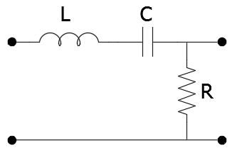

The impedance of such a circuit is as follows:

Assuming , the series resonance occurs at certain resonant frequency , when the impedance is minimum i.e.:

What leads to:

Exemplary impedance magnitude and angle plots of the system from Fig. XX are plotted at Fig. XX.

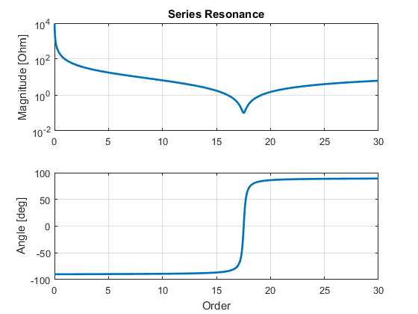

Since the impedance is minimum, the current can reach very high values:

Thus, we can see that the current is limited only by resistance. In the pure case the currents tends to infinity and if is very small, current can be high.

### Parallel AC resonance

The parallel resonance occurs in parallel RLC circuit (Fig. XX) when the impedance tends to maximum i.e.:

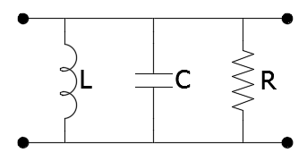

Thus, the resonant condition is:

Then again, the resonant frequency is as follows:

Exemplary impedance magnitude and angle plots of the system from Fig. XX are plotted at Fig. XX.

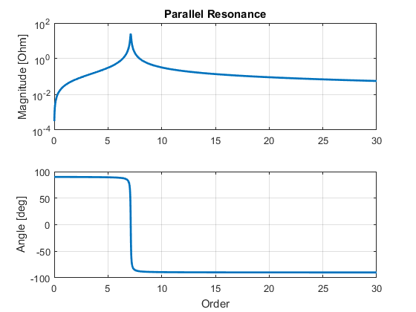

### Tank circuit parallel resonance

More practical LC circuit i.e. with inductor modelled with non-zero value of resistance and capacitor modelled without resistance is called Tank circuit [Das]. Fig. XX presents such a circuit.

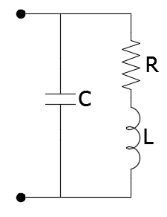

In this circuit the aggregate admittance seen from the terminals is as follows:

In other form:

The plot of impedance of the system is presented in the picture:

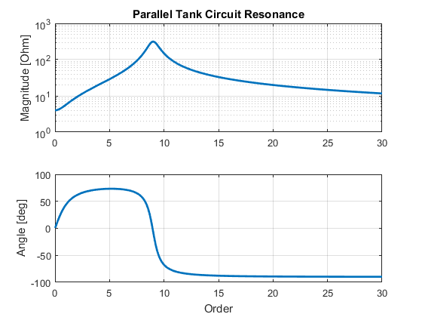

In the circuit with zero-resistance (lossless circuit), resonance occurs if impedance of inductor equals impedance of capacitor i.e. when the circuit behaves as short-circuited. In this case, resonance occurs in similar situation, even though the resistance stays unchanged in the circuit. In other words resonance occurs when power factor of admittance above equals zero:

That gives resonant frequency:

Moreover, as distinct from the series resonance, where resonance can occur from any value of resistance, in this case resonance occurs only if following equation is true:

In other words, resonance does not occur if:

## Factors affecting harmonic resonance

Some factors impacting harmonic resonance are the following [Das]:

• Synchronous and asynchronous machines and loads in the power system will

absorb some of the generated harmonics and change the resonance points. Their

correct modeling is an important factor.

• The harmonic impedance of the utility source must be ascertained and

accounted for. It is not merely given by the three-phase, short-circuit current,

when harmonic sources are present.

• The shunt power capacitors are not recommended to be applied in the presence

of load-generated harmonics. These must be turned into harmonic filters after

a careful study and applied at an appropriate location in the power system.

• Secondary resonance can occur when the shunt capacitors are applied at multivoltage

level in a distribution system. This is an important consideration. When a capacitor bank on the high side of distribution is switched, overvoltages of the order of four to five times can occur on the capacitor bank, which is in service at a lower voltage.

The load resistance plays an important role in the system resonance

(Fig. 9.5(b)). The impedance modulus and sharpness of the tuning of the ST

filters vary with resistance.

The motor loads should be appropriately modeled (Chapter 14). These appear

primarily inductive at harmonic frequencies.

The presence of single-phase loads must be considered.

The harmonic mitigation and passive filter designs should be properly applied.

Application of single-tuned or band-pass filter does not eliminate harmonic

resonance, but merely shifts the resonant frequency. A proper choice of passive

filter type has to be exercised (Chapter 15).

Harmonic analysis for transmission systems requires rigorous modeling. Also

the transmission systems undergo changes and the limitation of the computer

models and practical conditions apply (Chapter 14).

Resonant conditions may not be experienced all the time. A resonant condition

can vanish with a system change and vice versa.

Online measurements over a period of time are required to capture a resonant

condition.

• Subharmonic resonance is discussed in Chapter 5.

## Effects of harmonics

The harmonic resonance in a power system cannot be tolerated and must be avoided. The magnified harmonics will have serious effects on equipment heating, harmonic torque generation, nuisance operation of protective devices, derating of electrical equipment, damage to the shunt capacitors due to overloading, and can precipitate shutdowns.

## Nabe and Akagi instantaneous power theory

Nabe – Akagi instantaneous reactive power p-q- theory is based on Clark’s transformations in three phase systems. The power in electrical circuit is described using instantaneous voltage and current without the use of Fourier series. Usually is used for switching compensators and active filters controls [Das].

By linear transformation, the voltage va vb vc and load currents ia ib ic are transformed into an alpha-beta coordinate system. The instantaneous real power p and the instantaneous imaginary power q are defined on the basis of transformed voltages and currents. The following equations shows the transformations.





On the basis of this theory, with further conversions of the equation we obtain the instantaneous active and reactive powers.





Since the Paq and Pbq cancels each other, one can conclude that in the system of converter connected to source and load on both sides, there is no relationship between the instantaneous reactive power on the source side (between source and converter) and instantaneous reactive power on the load side (between converter and load). Therefore, the instantaneous imaginary power on the input side is not equal to the instantaneous imaginary power on the output side. However, the instantaneous real power on the input side is equal to the real output power.

# Analysis methods of harmonics propagation

The phenomenon of harmonic resonance seems well understood in the literature, however tools available to analyse it are very limited [Xu 2005]. Method of frequency scan (frequency sweep) is the most general and popular method to identify the resonance frequencies in the network [ref 2 in Xu, 2005]. However the method is limited. A resonance is between two elements (capacitive and inductive) in the system. Networks usually consists of many elements, therefore the result of frequency sweep does not indicate which elements exchange energy between each other, causing resonance.

The method of Harmonic Resonance Modal Analysis (HRMA) was developed to face this problem [Xu,2005]. This method involves only analysis of parallel resonance which is more dangerous in the power system. From HRMA buses that excite a particular resonances can be identified. Thus, we can conclude which components are involved in the resonance. Moreover, the method gives clues where the resonance can be observed more easily and how far the resonance can propagate in the system.

## Fourier Analysis

## Frequency Sweep

Frequency Sweep (or Frequency Scan) analysis is a characterization of the system equivalent impedance at a bus in the system as a function of frequency [Bradt 2012]. As the result, curve of impedance in frequency domain is obtained. The peaks in the curve suggest frequencies when parallel resonance occurs (very high impedance at certain frequency) while dips indicate the frequencies when series resonance occurs (very low impedance at certain frequency).

In Wind Power Plants often frequency scans are done at various grid locations or at the collector bus [Bradt 2012]. The magnitude of computed impedances depends also on the level of equivalent voltage used in the calculations. However, the single value of identified peak impedance does not determine if the resonance occurs. For harmonic problems, there must also be a sufficient level of harmonic source voltages or currents at or near the resonant frequency to excite the resonance [Bradt 2012]. Also, the impedance value itself has to be analysed in particular case to identify the value that can cause harm. To do this, the best way is to obtain specific data by measurements, but also data provided by manufacturers of devices in the network.

## Harmonic Resonance Modal Analysis

The method is based on analysis of well-known admittance matrix of the network - . It focuses on the large elements of inverted . In the extreme case (very large elements) the admittance matrix tends to singularity and element of inverted tends to infinity, thus very high voltages can be produced, which is in principle parallel resonance.

The elements are identified on the basis of eigenvalues of matrixes. Since matrix becomes singular when even one of the eigenvalue becomes zero, the principle can be clearly used. Eigenvalues correspond to certain mode of harmonic resonance, therefore the study consists of identification of critical resonance modes. The equations describing the method including the identification of certain buses and elements are presented below.

The admittance matrix on the network is constructed for certain frequency . Admittance matrix fulfils equation:

where: is the network admittance matrix is the nodal voltage and is the nodal current injection. All matrix values are at frequency .

To investigate if approaches singularity, the theory of eigen-analysis is applied. According to [Bellman, 1970], matrix can be decomposed into (index is neglected in the next equations for simplicity):

where is the diagonal eigenvalue matrix and and are the left and right eigenvector matrices.

Defining as the modal voltage vector and as the modal current vector, the equation can be derived:

or

where has the unit of impedance and is named modal impedance . From matrix equation (XX), one can easily identify the “location” of resonance in the modal domain due to corresponding modal currents and voltage [Zhenyu Huang 2005]. It is not related to or caused by a particular bus injection since it is in modal domain. Thus, the smallest eigenvalue is called the critical mode of harmonic resonance and its left and right eigenvectors are the critical eigenvectors.

The modal currents are a linear projections of the physical currents in the direction of the first eigenvectors. Also the physical nodal voltages are related to the modal voltages by: . More details in [Zhenyu Huang 2005]. In summary, the critical eigenvectors characterize the excitability of the critical mode (right critical eigenvector) and observability of the critical mode (left critical eigenvector) [xu2005]. The excitability and observability of modes are characterized with respect to the location. It is possible to combine the excitability and observability into a single index according to the theory of selective modal analysis [Perez-Arriaga 1982]:

The diagonal elements of the above matrix characterize the combined excitability and observability of the critical mode at the same bus. The definition [xu2005] is:

where is the bus number and is the mode number.

From these calculation on the basis of admittance matrix, after the process, it is obtained: the set of participating factors for each bus for each critical mode, so the modes when the modal impedance is the highest, which occurs for certain frequency at certain number of mode. The participation factors of all buses sum up to 1, therefore the comparison between buses is simple.

#### Critical Modes and Resonance Condition – comparison between FS and HRMA

As mentioned, resonant conditions identified in this method depends on the value of eigenvalue, which is very small if resonance occurs. This results in very high modal impedance. As seen from comparison with frequency scan impedance curves, the sharp peaks occur for the same frequencies. One has to remember that in frequency scan method, the impedance curves are seen from the certain point in the grid, while in HRMA the impedance curves are divided into modes, which does not correspond to the physical buses, even though the number of modes and the number of buses is the same.

Moreover the values of maximum impedances at peak point from both methods are different. The reason is again due to comparison between “real” impedance and “modal” impedance. Modal impedance should be investigated referring to every specific case in order to identify the threshold, above which the harmful resonance is produced. In this thesis, values of interests identified by both methods are the frequencies when resonances occurs.

# Harmonics in WPP

Wind Power Plants due to intermittency of the wind, are usually supported by great number of power electronic converters which enable effective operation of WPP. These non-linear devices are sources of significant amounts of harmonics in Wind Farms.

Harmonics produced by converters first of all are introduced into inner grid of WPP. Before any waveform produced by wind turbines and converted by wind turbines converters is introduced into the power system (through point of common coupling - PCC - between WPP and external grid), it is exposed to dangerous phenomenon of harmonic resonance in inner grid of WPP.

Internal harmonic resonance depends essentially on the elements that the inner grid consists of (including possible HVDC link converter) and the way of their connection (topology). It contributes to amplification of existing harmonics and is able to create new harmonic components.

External emission of harmonics (to the power system) from Wind Power Plants first of all depends on **(1) converter topology, (2) applied harmonic filters and (3) short-circuit current at PCC [Das]. These three features has to be completed by the above problem of (4) internal harmonic resonance** in the wind power plant inner grid.

If the wind farm is connected by HVDC link, then the emission of harmonics to the external grid depends on the DC/AC conversion at the PCC behind HVDC connection.

For harmonic resonance problems, there must also be a sufficient level of harmonic source voltages or currents at or near the resonant frequency to excite the resonance [Bradt 2012].

*Main focus of this thesis is understanding and description harmonic resonance appearing in inner grids of Wind Power Plants. Moreover, stability issues due to the harmonic resonance are put forward. As mentioned in Section XXXX, the analysis of these problems has recently become very important due to serious problems observed in first HVDC connected offshore wind farm during its first years of operation. For future implementation of HVDC connected offshore WPP the problem is currently investigated.*

## Converter topology

Topology of the converter is partially determined by the electrical machine that is used in wind turbine to generate electricity. According to the level of power that flows through a converter, full scale converter can be distinguished. It provides control over total power produced in generator. On the other hand, there are also Wind Turbine application where only part of the power produced can flows through converter. The ratings of the converter, so also its costs, are reduced, however control of the power produced in wind turbine is limited.

Within the full-scale converters, the most popular utilized in these days in wind turbines are: 2-level converters, 3-level NPC converters, multi-level converters, also matrix converters and tandem converters [Review, Pham 2013+].

Secondly, when it comes to the scale of the wind farm, as stated in [Das], the greater the number of turbines the lower is the magnitude of the harmonics and subharmonics, especially of the lower order.

*In this study, only models of full rate wind turbine converters are considered with some minor exception of networks with direct connections of SCIG to the collector grid. On the other hand, HVDC link converter is modelled with respect to principles described in the Section XXXX.*

## Applied filters

The two main methods for controlling harmonics in WPP are avoiding producing of harmonics and implementing filters to mitigate them [Bradt 2012]. To avoid the production of harmonics, network of WPP has to be designed properly, however implementation of harmonic filters anyway can be necessary due to topology changes or even very insignificant modifications which change resonance levels. The designing of filters should be based on measurements and simulations in order to control resonance properly.

Second method - implementation of filters - is the most common approach to the harmonic resonance [Bradt 2015]. The design and implementation of filters is not considered in this study, however the method presented of HRMA is vital for identification of the buses which are potentially more appropriate for filters installation.

## Short circuit current at PCC

From the grid side, the short circuit level at the point of application is also not fixed. It varies with operational condition in the grid. The weaker the external grid, the more it varies usually, therefore the resonant frequency can float around. These fluctuations are not considered in the thesis.

## Internal WPP resonance

The phenomenon of electrical resonance is described in section XXXX. As mentioned, if the resonance is not properly controlled, it leads to failures, instabilities, shut-downs or even damage of components. If the internal grid of WPP is separated from external grid for example by HVDC connection, electrical behaviour of the WPP grid can be different from the main grid.

In such a grid there is no rotating mass that establishes physical binding of power and frequency [BorWin1, 2015]. Thus, the frequency of internal WPP and the infeed from the WTs can be completely controlled by converters. Moreover, every converter has its own control schemes that can have a bandwidth of several hundred hertz. Thus, converters are able to amplify oscillations which are in the system [BorWin1, 2015].

*The resonance in Wind Power Plant is the main reason of the instability in first HVDC connected offshore WPP, described in motivation of the thesis part (section XXXX). This problem was not considered during the planning phase of the wind farm and should be extended.*

# Stability of WPP

In VSC converters the bandwidth of control signals are several times of the fundamental frequency. Such high-frequency control introduces dynamics above fundamental frequency, creating potential for high frequency instabilities and resonances that are not present in CSC [Liu, Sun 2014]. Since the VSC does not need reactive power support, also it has higher controllability and also ability of black start the system, this type of converter is getting more popular in new Wind Farms.

*In the offshore WPP Bard Offshore 1 VSC converters are utilized. However the problem of grid resonances caused by these converters was not considered during planning phase of the WPP. Therefore, stability problems due to converters interactions were not considered [BorWin1].*

As stated in [Sun 2011] and [Liu,Sun 2014] converters could go into resonance with the grid if the grid impedance exceed the input impedance of the converter. On the basis of this statement, the analysis of stability is performed. The essence of the method is presented also in [Middlebrook 1976]. Stability problems could happen due to more advanced nonlinear power electronics included in the converters. This problem does not occur between, for example, synchronous generators since power electronic elements influence in these elements is limited. The problem of converter impedance non-linear behaviour is described in Section XXXX.

## Harmonic stability

The new stability criterion based on Nyquist stability criterion is described in [Sun 2011] and is still under development [BorWin1]. The main advantage of this method is that it does not require all details about converter which are intellectual property of manufacturers and could be right choice at the planning phase of an investment. Only frequency dependent impedances of converter are needed [BorWin1]. The method also avoids the need to remodel each inverter and repeat its loop stability analysis when the grid impedance changes [Sun 2011].

In contrast to EMT simulations and eigenvalue analysis only relatively simple stability criterion is developed. Thus, this method is very fast and can evaluate new topology if any switching action occurs [BioWin1]. The simplicity is achieved by aggregation of all wind farms with their controllers into one element. Then, the aggregated system is evaluated by Nyquist stability criterion that provides information about gain and phase margin. As mentioned, the manufacturers have to provide only frequency dependent impedance of their generation unit (converter), including passive elements impedance and impedance changes due to active controls [BioWin1].

Main advantage of the method is that the frequency dependent impedance can be calculated with analytic model (providing data from manufacturer), calculated with an   
EMT-tool but also measured at a real generation unit.

## Stability evaluation model

With the proper data and assumptions described above, we use the simple model to evaluate the stability consisting of voltage source with internal impedance and the impedance of the grid (Figure XX) [Sun 2011] [BorWin1].



In such a network the current depends on both Zs and Zg impedances:

The equation of the network Ig current (eqXX) can be expressed in as loop gain for the system in the Figure XX.



On the basis on the equation (eqXX) we conclude that the system is stable if the source has a zero and the load an infinite output impedance. For stability the value of ratio has to be at least below 1 to for all frequencies [Sun 2011] – in other words – the system is table if satisfies the Nyquist stability criterion [Middlebrook 1976].

The first problem with the model above is the point division between and . The best point of division is still under investigation [BioWin1]. In this study the network is divided behind the HV transformer from the HVDC link point of view (Bus 2).

There is also other conceptual problem with the presented method. As either the inverter of WT of HVDC inverter could be treated as the source, the results about stability conclusions are very different [Sun 2011]. In this study we perform only one approach where the aggregated WT converter is treated as “source” and HVDC link converter as “grid” and the point of division is always as described above.

Finally, the stability criterion requires frequency impedances of converters which could be modelled as either voltage or current sources. The problems and details about these two models are explained in [Sun 2011]. The “source” part and the “grid” part of the network can be modelled by its Thevenin equivalent circuit (voltage source) or Norton equivalent circuit (current source).

The Thevenin model for stability criterion was presented above. However, it is also possible to represent converters by current source [Sun 2011] (Fig. XX).



The stability criterion is, analogically to (eqXX), based on the system equation:

where, for stability, the ratio of the load input impedance to the source output impedance should meet the Nyquist stability criterion.

Comparing (eqXX) to (eqXX) one can see that stability requirement for CS system is opposite to that for VS system. The distinction between these models is described in [Sun 2011]. The author states also that the most common grid model is hybrid system combining current and voltage sources (Fig. XX). Applying hybrid model to the case of this study, the wind turbine inverter is modelled as a current source while, the HVDC rectifier is modelled as voltage source.



The assumptions of the stable system without the inverter and the stable inverter when grid impedance is zero are still applicable.

Then, the current in the system is:

And the Nyquist stability criterion of this system is: .

## Stability assessment

From the examples and assumptions described above, we assess the stability of the network as follows [BorWin1].

Both impedance curves of “source” and “grid” are plotted in a Bode diagram for positive and negative sequences. From Bode diagram, each intersection of grid curves with source curves could be critical and has to be investigated. For each intersection, phase margin between appropriate curves (curves that intersects) will be calculated according to:



where deltaFi is the phase difference between curves in degree. If the phase margin calculated in such a way is below 30 degrees the system **can be** instable [BioWin1]. As aforementioned the stability assessment is performed for specified point of division and specified “source” and “grid” sides.

# Modelling of elements

## Transformers:

For harmonics modelling of transformers in electrical grid models for very high frequencies a generally not necessary. For higher frequencies resistance increases, while the leakage inductance reduces [Das,ch12]. In this study, two- and three- winding transformers impedances will be represented simply by its resistance and inductance as follows:

where and corresponds to fundamental frequency resistance and reactance. The skin effect and eddy currents effect the resistance at higher frequencies, therefore we do not consider these effects.

## Cables

Modelling of cables is important in harmonic analysis since they are very significant source of capacitance in considered grids. For harmonic frequencies up to 3000Hz the resistance of cables will increase. The slight effect of decrease in inductance and shunt capacitance can be ignored [Das,ch12]. PI models are considered as appropriate for frequency scan analysis, but not for transient analysis.

Usually, exact frequency-dependent model is obtained by Finite Element analysis [Das,ch12], however in this study exact methods of cable models are not considered. Elements of Pi model of the cables is described by:

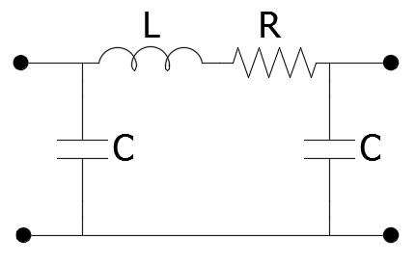

## Filter reactor

Filter reactors modelling is important since it significantly affects the tuning of whole system. Resistance of the filters at high frequencies can be calculated as follows:

– for aluminium reactors

– for copper reactors

In the models presented, resistance of LCL filter and resistance of phase reactor is neglected (equals zero).

## Power converters

Modelling of power converters is the most crucial and challenging within all elements. Power converters devices are very nonlinear and their impedance behaviour strongly depends on many factors. The exact model should be derived on the basis of control codes, ideally also on the basis of measurements on the real device.

Control codes are very unique and never published by the manufacturers. They are their intellectual property and thus the determination of the exact frequency is very difficult [BorWin1, 2015]. There are also more simple approaches to face the problem of converter modelling. The principles presented below are considered for frequency domain analysis. EMT (electromechanical transient) analysis is not considered.

### Voltage Source “VS” and Current Source “CS” models

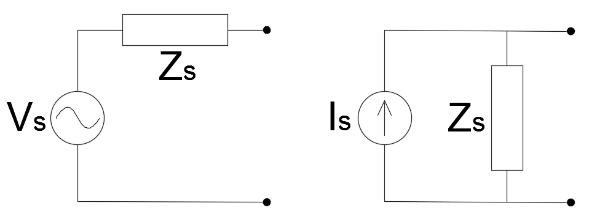

It is common to approach modelling of converters as either current or voltage source. As stated in [BorWin1], current sources should be only used if the **grid impedances are similar.** Otherwise it leads to very inaccurate harmonic current values and wrong results. Therefore, voltage sources should be modelled instead and the input impedance should be considered.

There is very important fact to be considered for both approaches in frequency domain analysis. According to circuit theory, ideal voltage source internal resistance is zero (short-circuit). On the other hand, the ideal current source internal resistance is infinite (open-circuit). Therefore, in frequency domain analysis the impedances of ideal voltage or current sources is zero.

In this study, models with either ideal current source or voltage sources are considered for comparison in FS method and HRMA method. For those models, internal impedance of source (VS or CS) is zero. The third model of converter is described in the following section and is based on voltage source with nonzero, nonlinear internal impedance (nonideal VS). For stability study the principles of converters modelling and stability assessment are described in section 5.2-5.3.

### Frequency dependent impedance model “Z(s)”

The models of either voltage source or current source described in the previous section are very important however for the resonance analysis, the value of series impedance (in case of voltage source) or parallel impedance (in case of current source) is crucial. The voltage and current sources themselves should be open-circuited or short-circuited, respectively. The approach developed in [Liu Sun 2014] and [Liu Sun 2013] of frequency dependent impedance of converters is introduced to this study and described below.

The assumed converters modelled are: 2-level VSC Wind Turbine DC/AC inverter and the same type of HVDC AC/DC rectifier. Models of these converters are then used in the simulation.

#### Wind turbine converter (inverter)

For the control purposes, wind turbine converter is controlled as current source. Due to this fact, the device behaves more like current source and will be modelled in this way. Reactive power supply and voltage regulation of the model is not considered. A phase-locked loop (PLL) is included in the model for AC bus synchronisation [Liu Sun 2014].

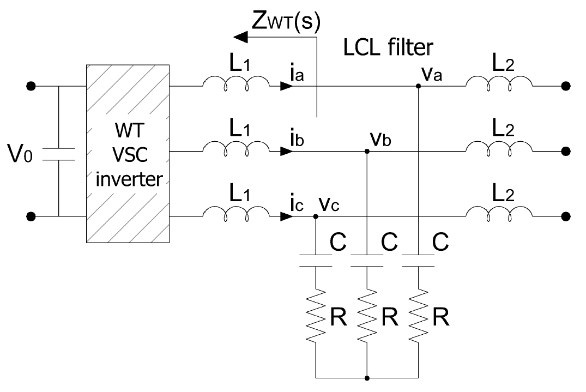

The wind turbine model is described in dq-frame. As mentioned, the current control scheme is used. The reference value is the current provided be the DC link voltage regulator. The current compensator transfer function is given:

The PLL is implemented using PI regulator. Including the integrator to convert frequency into angle, the PLL compensation transfer function becomes:

The values of parameters are included in Chapter II.

For the stability study, the wind turbines are lumped into one device (one impedance). The output impedance of WT inverter is developed using the harmonic linearization method described in [Bing Karimi 2009]. As the result, converter is described by positive-sequence and negative-sequence impedances without cross coupling [Cespedes Sun 2014]. Providing constant DC bus voltage (as the reference) the impedances become:



where is fundamental angular frequency, is the loop gain of dq-frame PLL defined by:

and and are the current an PLL compensator transfer functions, as defined before.

#### HVDC link converter (rectifier)

In case of HVDC converter, the device is controlled to behave as a voltage source at the ac terminals [Larsen 2012]. Figure XX demonstrate the model for HVDC converter impedance calculation.

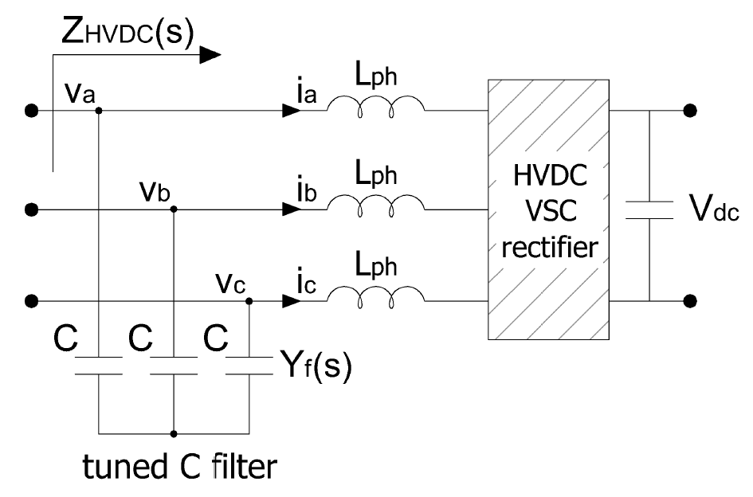

The HVDC rectifier voltage control is performed by a PI regulator in the dq-reference frame [Sun 2014]:

A current loop is embedded within the voltage loop and the current compensator transfer function is defined as Sun 2014]:

Other control approaches could be incorporated but are not considered. The values of parameters are included in Simulation Part.

Again, the assumption of constant dc link voltage () is made. The resulting positive- and negative-sequence input impedance are given by:



where is fundamental angular frequency, is admittance of the ac filter, and are defined as:



and and are the current and voltage compensator transfer functions defined before.

# Harmonics and power quality regulations

In this chapter the harmonic distortion limitations according to some standards are described. It is worth of mentioning that harmonics are not the only problem of power quality in power system. Power quality includes more electromagnetic phenomena which are categorized on the basis of duration (from nanoseconds, like lightning strokes) to steady state disturbances (e.g. harmonics and interharmonics) [Das]. The other than harmonic frequency power quality issues are not of concern in this study.

Moreover, considered HVDC connected off-shore WPP is not directly connected to the external grid. The connection is realized through HVDC link, therefore the harmonic phenomena occur before PCC i.e. within the inner WPP grid. Before being emitted to the main grid distorted waveforms are converted to DC waveforms. However, the harmonic content of the inner WPP grid influences the performance of the HVDC converter, therefore the limits should also be considered.

One of the standard that provides information about harmonics and interharmonics and is internationally accepted is [X] IEC Standard Series 61000. Moreover, there are EN standards like [X] EN 50160 approved by European standardization body CENLEC. EN standards are official standards for European Union. In North America, the harmonic limits are described in [X] IEEE 519. All three mentioned standard are internationally accepted. [Das]

These standards establish emission requirements such as harmonics, voltage fluctuations, radio frequency disturbance, immunity requirements etc. Some of these requirements are summarized in the sections of this chapter. However, most of the information included would not be utilized in further analysis, even if applicable to the inner WPP networks, since the EMT simulations are not performed in this study. In other words the waveforms for which the harmonic content is assessed do not appear in this study.

The important concept for harmonic emission is point of common coupling (PCC). PCC is the point of metering of power supply for both utility and consumer or any point where both parties can access the point for direct measurement, also for harmonic indices measurements. It is usually also the point where another consumer can be served from the same system. [Das]

## Harmonic current and voltage (IEEE 519)

# Environmental impact

# Temporary planning and cost

Budget of the Master Thesis development work:

Cost of Work Effort = noWeeks [weeks] * hoursWeekly [h/week] * payRate [€/h]

20 weeks * 40h/week *

Cost of Software = DIgSILENT Licence + MatLab Licence

1500€ + 2000€

Indirect costs = light + desk + water + office rent… (25% of direct costs?)

+VAT

1. Simulations

- comparison of resonance results for three different topology cases by frequency sweep method and harmonic resonance modal analysis, with simple converter model (VS or CS). Moreover, results from Matlab compared with DIgSilent as well. Finally, also identification of "source" elements of harmonics emission.

- comparison of resonance results for different converters models (both WT and HVDC converters) i.e. modeled as (i) VS, (ii) CS and as (iii) nonlinear frequency dependent impedance derived by harmonic linearization and some control principles. Moreover, comparison to case with (iv) no converter but with SCIG. This comparisons performed for only one chosen topology case.

- stability study on the basis Nyquist stability criterion by analysis of bode diagrams. This analysis for all three topology cases, with only the most advanced converters models with nonlinear impedances.

# System description

An offshore wind power plant with VSC-HVDC connection to the onshore grid is considered for study or harmonic resonances. The total amount of wind turbines power installed is 400MW. The WPP considered has a radial topology consisting of four-branch network. It is assumed that each string of wind turbine (WT) has the same parameters. The layout of the WPP is presented in the Fig. XX.

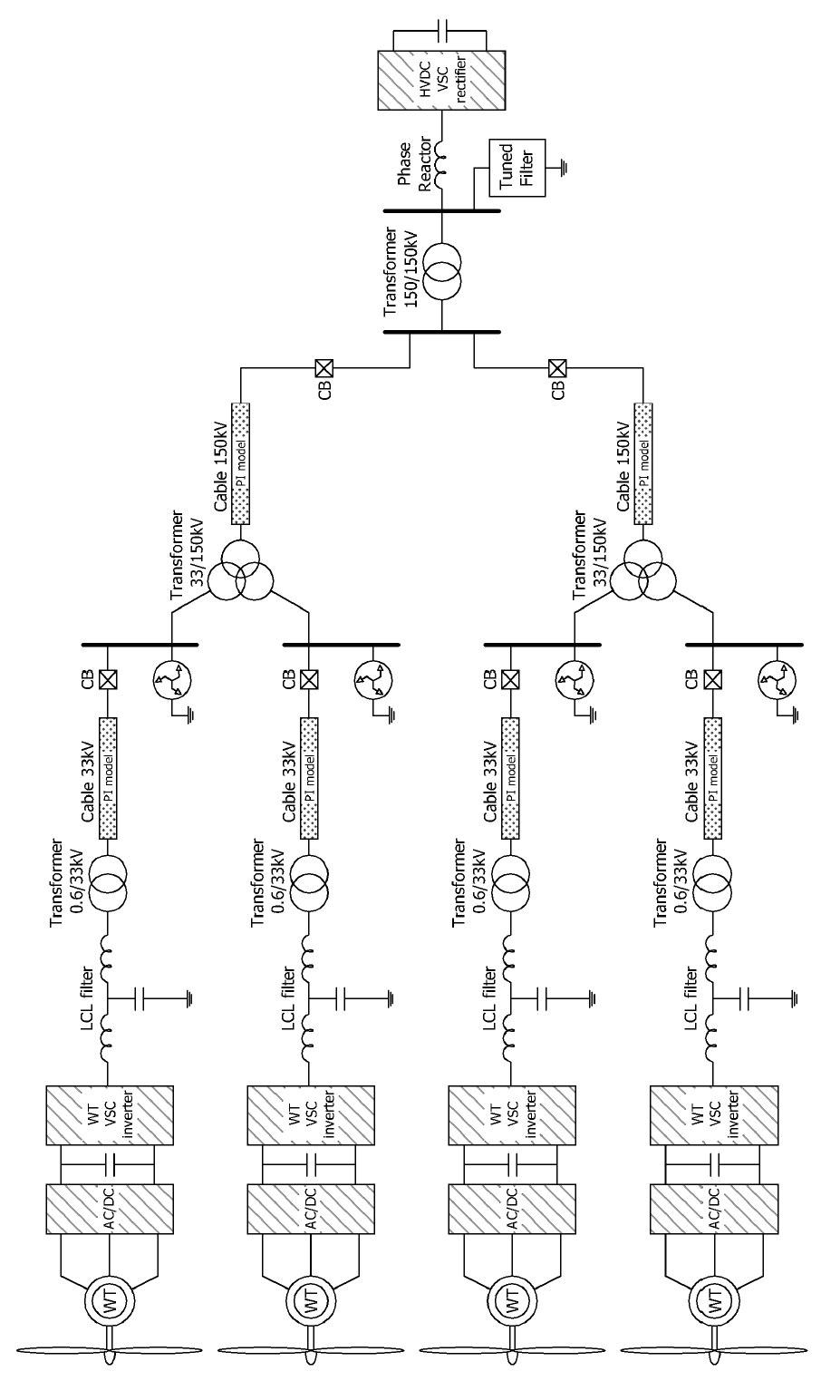

Each branch is formed by ten 10-MW wind turbines with a terminal voltage of 690V. The aggregated model is used where each ten turbine is lumped and modelled as a single turbine, represented by a 100 MW turbine. Aggregated turbine is connected to an LCL filter, a 690V/33kV transformer and an 8km underground collector cable of 33kV. Collector cable is linked to a 150kV transmission line with a length of 58km via a 150kV/33kV/33kV three winding transformer with YNdd configuration. The three-winding transformer is tied to the VSC-HVDC rectifier through a 150kV/150kV transformer and a phase reactor with an AC tuned filter.

## Network impedance model

Equivalent impedance model of AC only system is presented in Fig. XX. All of the parameters are recalculated according to the 150kV voltage level. Table XX shows the values of parameters in the network. The impedances of VSC-WT inverters and VSC-HVDC rectifier are calculated on the basis of different methods presented in Section XX. The resulting impedances are presented in Section XX.

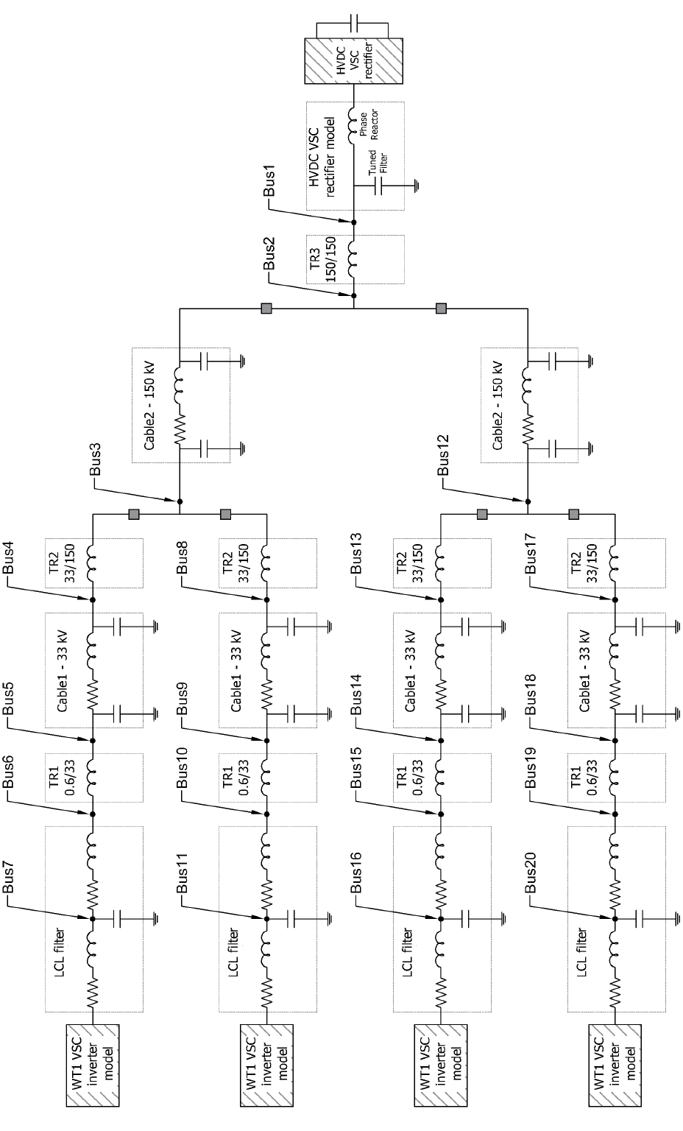

|  |  |  |
| --- | --- | --- |
| Component | Symbol | Value at 150 kV |
| Phase reactor |  |  |
| Tuned C filter |  |  |
| Converter transformer |  |  |
| Cable |  |  |
|  |  |
|  |  |
| MV/HC three-winding transformer |  |  |
| Cable |  |  |
|  |  |
|  |  |
| LV/MV wind turbine transformer |  |  |
| LCL filter |  |  |
|  |  |
|  |  |

## Topology cases

In the study, the comparison of different topologies is also performed. There are three topology cases taken under consideration. The difference between the considered topology depends on the number of branches with aggregated WT’s (1, 2 or 4 branches):

* Case 1 model consist of one aggregated WT. In this case only one out of four branches (on the lower side of the three-winding transformer) is connected. Since, both branches connected to the other 150kV line are disconnected, that line is also disconnected. The topology of this system is presented in the Figure XX.

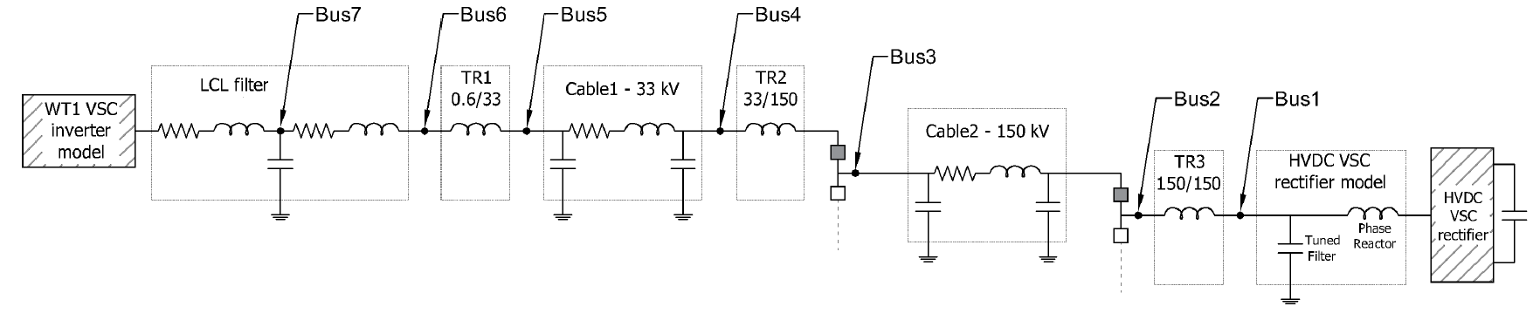

* Case 2 includes one more aggregated turbine branch than Case 1. The second WT branch is connected to the same three-winding transformer. The second 150kV line is still disconnected. The topology of this system is presented in the Figure XX.

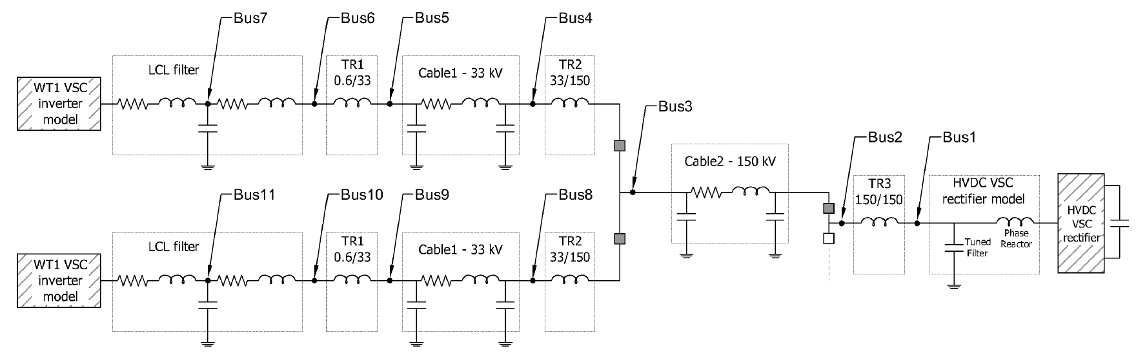

* Case 3 consist of all elements in the networks. All branches are activated, therefore all elements are included in analysis. This topology is presented above in the   
  Figure XX.

## Power converters models

All of the elements excluding converters are modelled as the RLC elements. The principles of modelling of the elements are described in Section XX. This section explains also the three different approaches to model converters. In the thesis, these models are simplified to the names: *VS –* where both WT and HVDC converters are modelled as voltage sources, *CS-WT* or simpler *CS* – where WT converter is modelled as a current source and HVDC converter is still represented by voltage source, *Z(s)* – where both converters are represented by non-linear impedance models. The procedure to obtain these non-linear models is described in Section XX and XX. The results of this analysis is shown in the Figures XX and XX i.e. the magnitude and angle of positive and negative impedance of the aggregated WT converter and HVDC converter.

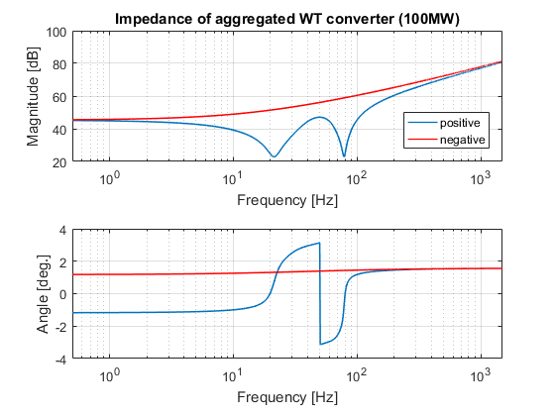

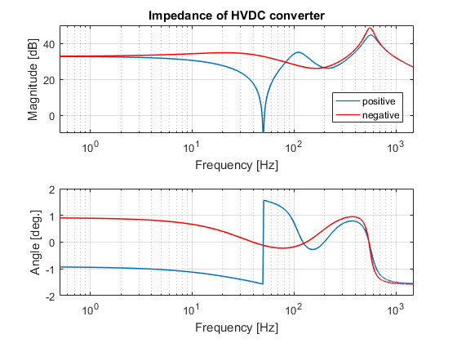

As described in [Sun 2014],

# Comparison of resonances with regard to topology cases and converter models

The objective of this section is to compare results of harmonic resonances frequencies for three topology cases (Section XX). The description of modelling converter as VS, CS and Z(s) model can be found in Section XX. Secondly, on the basis of Harmonic Resonance Modal Analysis, we identify the resonant frequencies again and additionally we spot the buses that have the most significant influence on the particular resonance frequencies. This identification is very useful for further study of implementation of tuning filters, however it is not investigated in this study.

## Case 1

### Frequency Sweep

The figure XX presents implementation of the frequency sweep method. All three models are included. The frequency sweep always refers to the particular node in the network. For this study, the bus number 7 (see Figure XX) is the bus of observation. In other words, the impedance is seen from that point in the network.

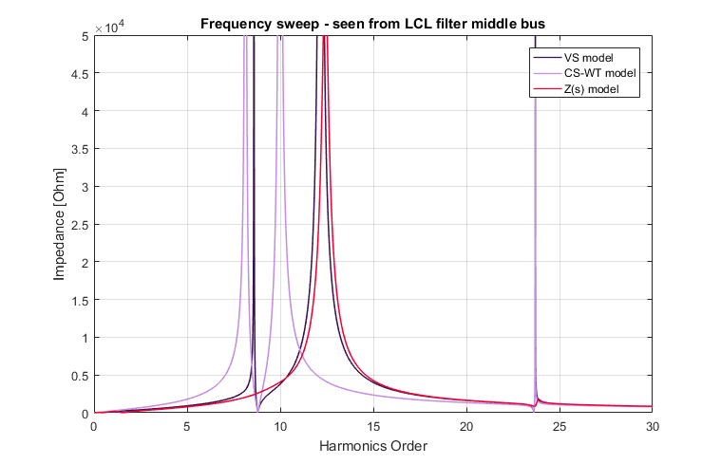

For the better visibility, the figure XX presents the same data but with logarithmic vertical axis.

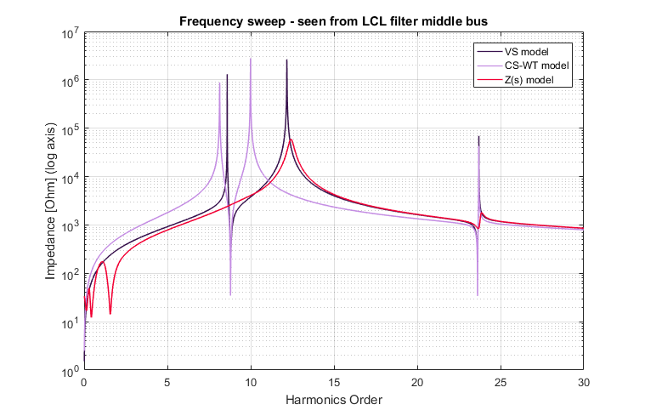

We can clearly see that the resonance frequencies vary for different models of converters. Table XX presents approximate resonance frequencies values. The values of frequencies are identified when impedance reaches local extreme values.

|  |  |  |
| --- | --- | --- |
| Converter model | Frequency order [-] | Peak impedance [Ω] |
| VS | 8.59 | 1304 k |
| 12.17 | 2655 k |
| 23.7 | 69 k |
| CS-WT | 8.14 | 880 k |
| 9.99 | 2787 k |
| 23.69 | 43 k |
| Z(s) | 12.42 | 59 k |
| 23.87 | 2 k |

Due to the issues with the Z(s) model presented in Section XX, the result of resonance around fundamental frequency is ignored.

For VS model, within the observed scope, we observe three resonance frequencies. Similarly, in case of CS model – there are three resonance frequencies. For the Z(s) model of converters only two resonance frequencies are detected (the lowest resonance is ignored due to the inaccuracies mentioned before).

Moreover, the values of impedance for Z(s) model are reduced comparing to the VS and CS models. The principles of modelling converters by this method leads to higher values of damping. The detailed description is provided in Section XX and in [Sun 2014] [Liu Sun 2013] Why lower values for Z(s)?

### Harmonic Resonance Modal Analysis

We compare the results of frequency sweep to the results of Harmonic Resonance Modal Analysis. As mentioned in section XX, with this method we returns the values of participation factors which suggest probable buses and this the elements which influence resonance more than others. The figures XX, XX and XX present the curves of modal impedance in domain of harmonic order.

The figure XX illustrates the modal impedance for three models. Only maximum modal impedance for each harmonic order is selected and plotted.

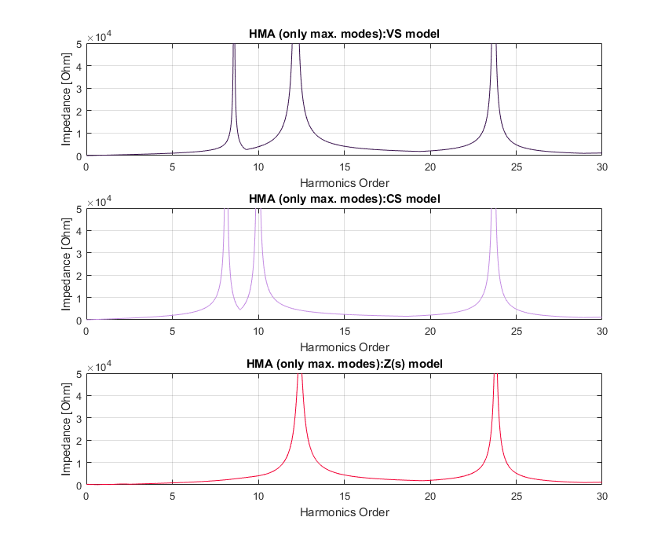

In the figure XX, we can observe the very similar shapes of curves, however, this time all the modes are drawn. Most of the modes are barely visible since they equals zero or very small values for all frequencies.

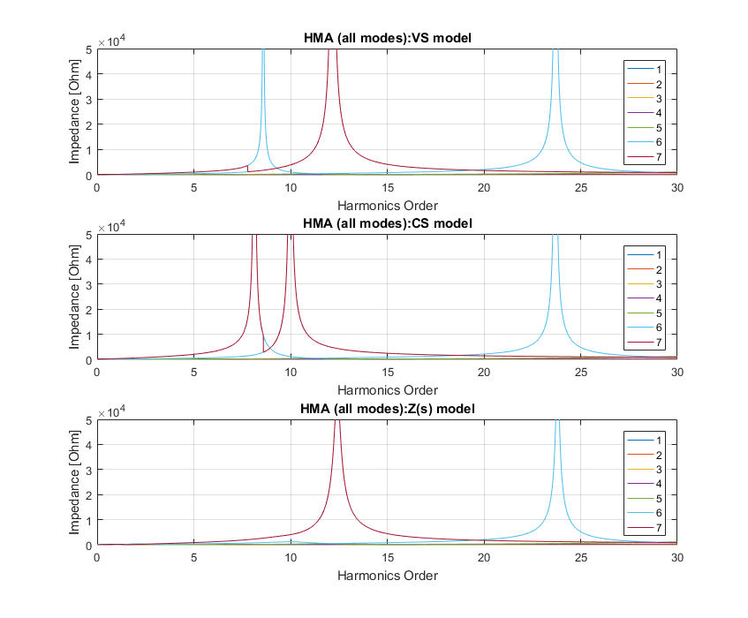

The graphs above feature two modes without a doubt - modes 6. and 7. Modal impedance for these modes reaches much higher value at the frequencies of resonance. The modes that determine the resonances are called critical modes. The critical modes impedances are plotted in the figure XX.

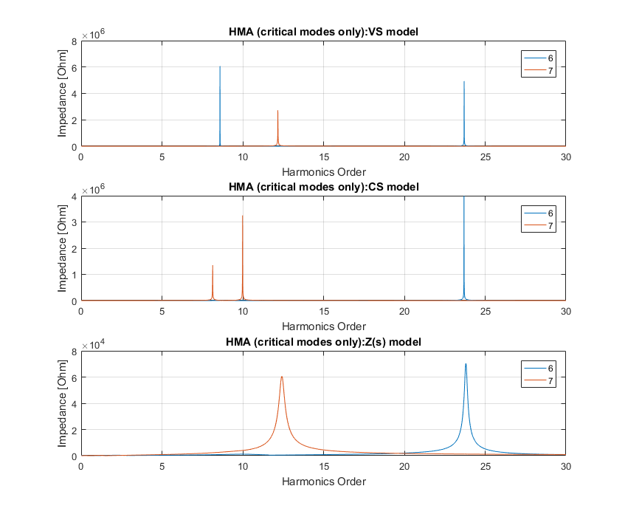

Even though the total number of modes equals the number of buses in the network, these modes do not correspond to each other exactly. Their correlation is reported by the participation factors presented in tables XX-XX. Before, the tables XX-XX presents the critical modal impedance values and the harmonic orders for frequencies when the critical modal impedances occur.

|  |  |  |  |
| --- | --- | --- | --- |
| Order | Critical mode | Critical impedance  magnitude [Ω] | Angle  [⁰] |
| **VS model** | | | |
| 8.59 | 6 | 6072 k | -79.9 |
| 12.17 | 7 | 2727 k | -81.3 |
| 23.7 | 6 | 4928 k | -20.5 |
| **CS-WT model** | | | |
| 8.14 | 7 | 1351 k | 84.6 |
| 9.99 | 7 | 3252 k | 74.5 |
| 23.69 | 6 | 3992 k | -40.5 |
| **Z(s) model** | | | |
| 12.42 | 7 | 61 k | 5.5 |
| 23.81 | 6 | 70 k | 2.0 |

|  |  |  |  |  |  |  |  |  |
| --- | --- | --- | --- | --- | --- | --- | --- | --- |
| Order | Participation factors [%] for the buses | | | | | | | PF’s sum |
| 1 | 2 | 3 | 4 | 5 | 6 | 7 |
| **VS-model** | | | | | | | | |
| 8.59 | 8.8 | 12.8 | 13.0 | 14.2 | 14.6 | 15.1 | **21.5** | 1.000 |
| 12.17 | 0.1 | 0.0 | 0.0 | 0.2 | 0.4 | 1.8 | **97.4** | 1.000 |
| 23.7 | 0.9 | 14.6 | 15.7 | 23.1 | **24.3** | 20.0 | 1.4 | 1.000 |
| **CS-WT model** | | | | | | | | |
| 8.14 | 2.6 | 4.4 | 4.4 | 6.2 | 7.0 | 9.3 | **66.0** | 1.000 |
| 9.99 | 1.1 | 1.0 | 0.9 | 0.2 | 0.0 | 0.3 | **96.5** | 1.000 |
| 23.69 | 0.9 | 14.6 | 15.6 | 23.2 | **24.4** | 20.2 | 1.1 | 1.000 |
| **Z(s) model** | | | | | | | | |
| 12.42 | 0.2 | 0.1 | 0.1 | 0.2 | 0.5 | 1.8 | **97.8** | 1.007 |
| 23.81 | 1.0 | 14.5 | 15.6 | 23.1 | **24.3** | 20.1 | 1.4 | 1.000 |

The study of participation factors is very relevant for localization of the best nodes in a network for filter implementation. The participation factors express the significance of a bus in resonance creation. Therefore, the modification of capacitance/inductance at the point of the network with the highest participation factor should trigger to the most powerful change of the resonance frequency. The details about participation factors in Section XX and [#].

In the study of Case 1, from the values of participation factors, one can easily diagnose that the buses number 5 and 7 are the two buses which contribute to the resonance frequencies more than the others. As we can see, these two buses play the lead role in all three different models what indirectly confirms the accuracy of the method. From the values of the participation factors, one can conclude about the different number of resonance frequencies in the last model Z(s) presented. Since the two resonance frequencies from the first two models are mostly correlated to the bus 7 and similarly for the one of the resonance frequencies from the last model (higher PF at bus 7), in the last Z(s) model, the two resonance frequencies could have been merged into one resonance frequency. Otherwise, due to the higher resistance of the Z(s) model, one of the resonance frequency could have been shaved to the insignificant value.

### DIgSILENT Power Factory “Frequency sweep” analysis

In this simulation, we use the Power Factory model presented in the figure XX. The model is combined of basic RLC elements.

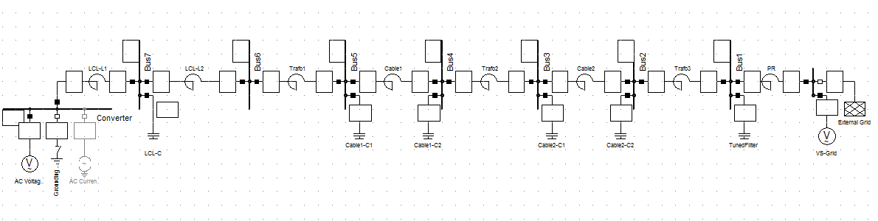

The two models: VS and CS-WT are simulated. The software performs *Impedance Frequency Characteristic* calculations. Figures XX and XX show the results of frequency sweep for VS and CS-WT model.

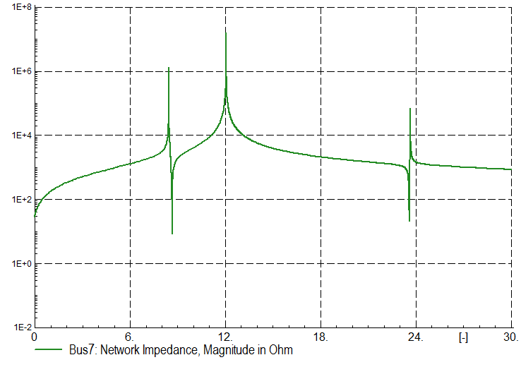

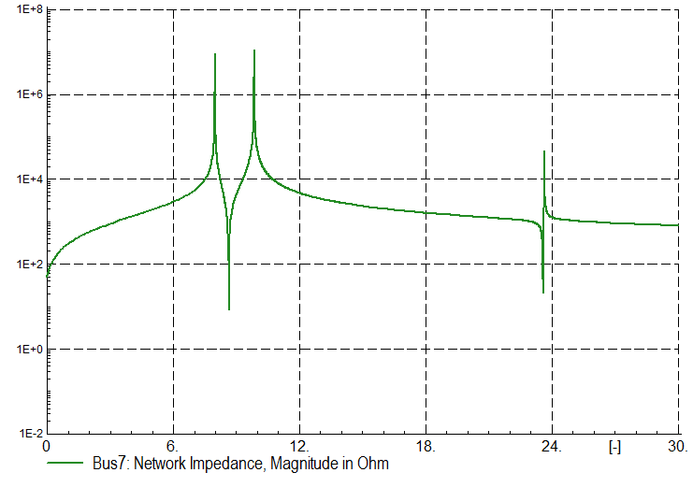

We can examine the figures obtained from the Power Factory software and conclude that they are coincident with the ones received from detail analysis in MATLAB. However, the peak values of impedances are different. The differences probably sources in the settings of *Impedance Calculation* for *Frequency Sweep* analysis. The step size of the simulation was set at the value of 0.1 Hz; furthermore the *Automatic Step Size Adaptation* was selected. Hence, difference in the values of impedance occurs. The dependence of the peak values from the value of step size was checked through similar simulation with different step sizes. The observation confirms that the step size influences the peak values.

What is more important in this study are the values of the resonance frequencies. The values obtained by Power Factory confirms the values gained from MATLAB analysis of both frequency sweep and modal analysis.

|  |  |  |  |
| --- | --- | --- | --- |
| Order [-] | | | |
| VS model | 8.59 | 12.17 | 23.7 |
| CS-WT model | 8.14 | 9.99 | 23.69 |

As aforementioned, the observation of network impedance (frequency sweep) is performed from the specified bus in the network (bus 7). Due to the Power Factory software, we can performed the observation of impedance from each of the bus in the considered case. The results of frequency sweep seen from all 7 buses is presented in the Figure XX and XX, for VS model and CS model, respectively.

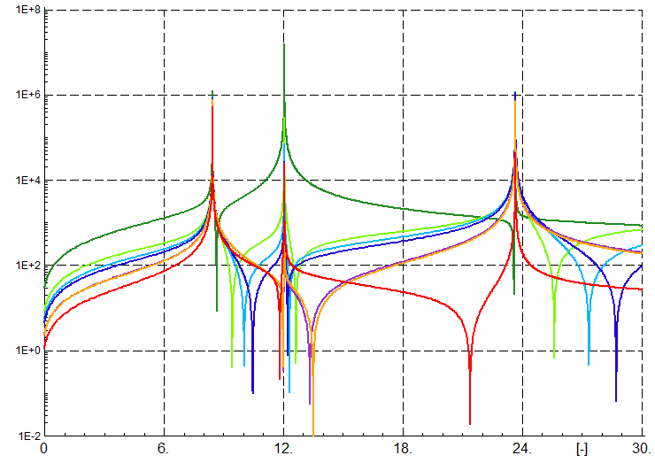

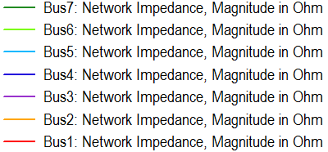

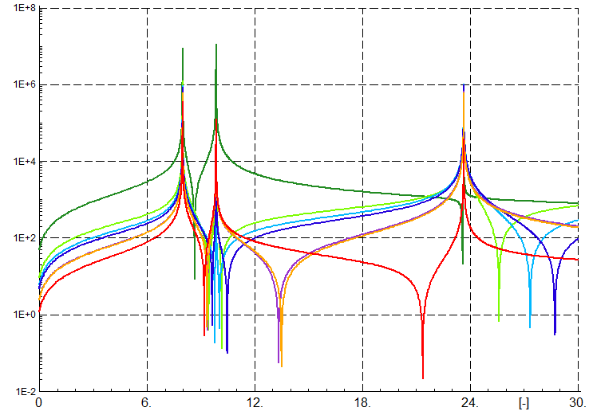

The examination of the curves above demonstrates that the peaking impedances for both models occurs at the same frequencies, regardless the bus of observation. On the other hand, the dips of impedance undoubtedly depend on the bus where the observation is performed from. Coupled with the principles of parallel and series resonance, we can draw the two conclusions. Firstly, the series resonance frequency depends on the bus in the network i.e. series resonance frequency is different at the different points in the network. Secondly, since the peaks of the impedance, so the parallel resonance frequencies, are the same regardless the bus of observation, we conclude that the parallel resonance frequencies do not depend on the point of observation. The confirmation of the latter statement we recognize in the HRMA method. As described in Section XX, the method is utilized in order to investigate the parallel resonance and is not performed for particular bus, but for entire network. The frequencies collected from that method are exactly the frequencies obtained for every different case of observation bus in the frequency sweep method.

### Results comparison

In the three previous sections the results of frequency sweep analysis, harmonic resonance modal analysis, both performed in MALAB were presented. Moreover these results we couple with *Frequency sweep* tool in Power Factory software. The values of resonance frequencies obtained ambiguously confirms the correspondence of these three approaches to the problem. The values of parallel resonant frequencies are the same for the considered accuracy.

The difference of the impedance peak values are not considered very deeply in this study. However, as aforementioned, these values very often depends on the step size of the calculation. Moreover, the threshold impedance values above which the impedance level is defined as dangerous should be assigned individually for each case. Furthermore, the values of modal impedance from HMA method does not exactly correspond to the real impedance value and should not be compared directly to the values of impedances obtained from frequency sweep or Power Factory tool.

## Case 2

The topology Case 2 was presented in Section XX. In this case, the Wind Power Plant consists of two branches. There is one aggregated Wind Turbine in each branch. The total power of connected Wind Turbines is 200 MW.

### Frequency Sweep

In the Figures XX and XX the results of frequency sweep method are presented with linear and logarithmic impedance scale, respectively. Again, all three models of converters are included. The impedance of the grid is seen again from the bus number 7 i.e. middle bus of LCL filter in the first branch. Since the branch 1 is equal to the branch 2, we can obtain the same curves for impedance observed from bus 11.

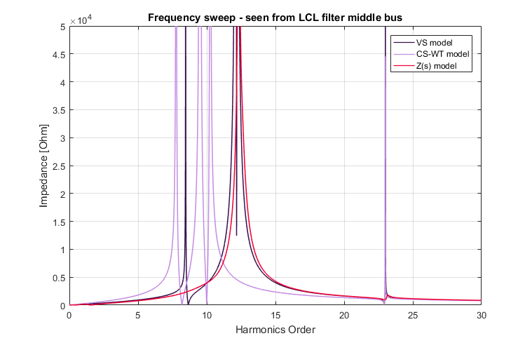

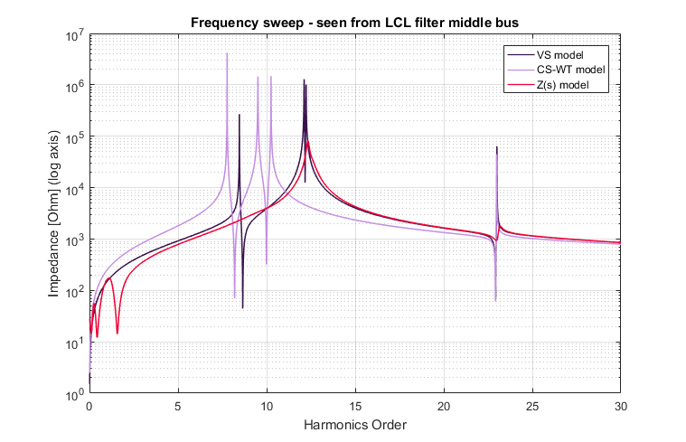

Table XX presents approximate resonance frequencies values. The values of frequencies are identified when impedance reaches local extreme values.

|  |  |  |
| --- | --- | --- |
| Converter model | Frequency order [-] | Peak impedance [Ω] |
| VS | 8.46 | 269 k |
| 12.12 | 1289 k |
| 12.23 | 1007 k |
| 23.00 | 64 k |
| CS-WT | 7.77 | 4217 k |
| 9.51 | 1455 k |
| 10.25 | 1475 k |
| 22.98 | 45 k |
| Z(s) | 12.33 | 82 k |
| 23.18 | 2 k |

Due to the issues with the Z(s) model presented in Section XX, the results of resonance around fundamental frequency are ignored.

This time we can note that undoubtedly there are four resonant frequencies for Current Source model. The curve of VS model consists surely of three peaks, however the last one is very close to the one around 12th order therefore is harder to notice it from the graph. The Z(s) model comprises two impedance rises, excluding ones around fundamental frequency. The value of impedance of Z(s) model is significantly lower than in other models, similarly to the Case 1. We carry on further conclusions and contemplations about the resonant frequencies after presentation of HRMA results for this case.

### Harmonic Resonance Modal Analysis

The Figures XX-XX illustrate the HRMA result curves. Similarly to the previous case, the following graphs shows the curves of maximum modal impedances for each harmonic order, modal impedances with respect to the each mode separately and critical modes only i.e. the modes that are assigned to the modal impedance peaks.

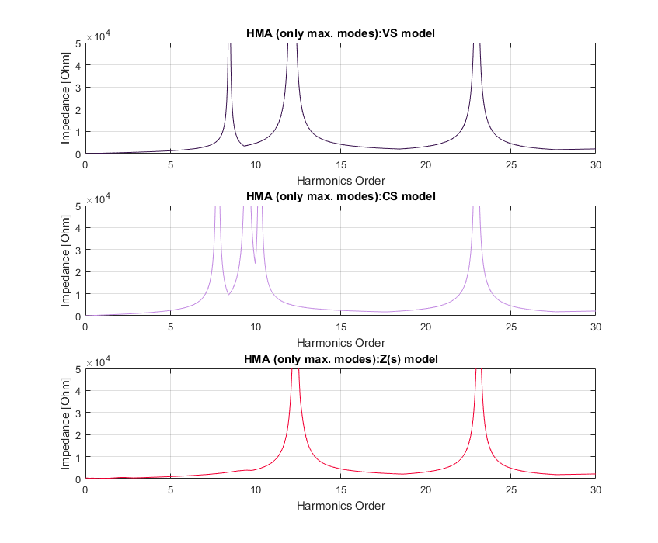

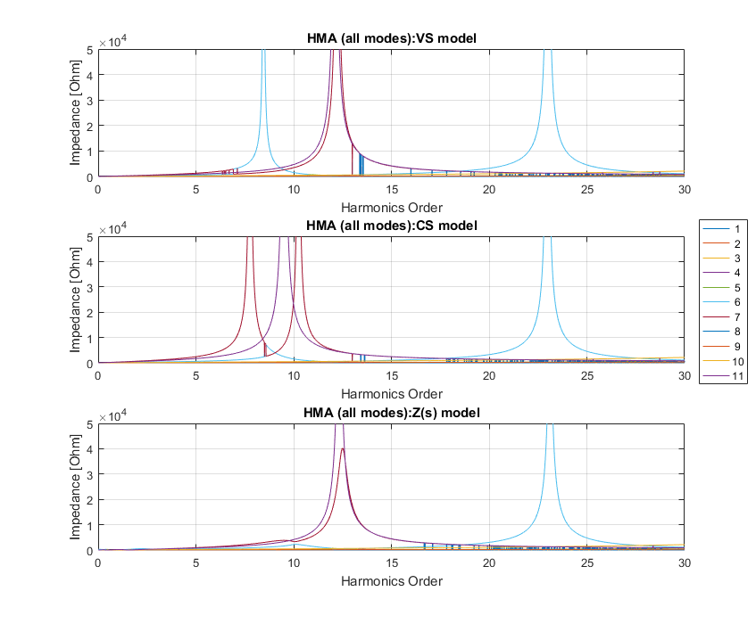

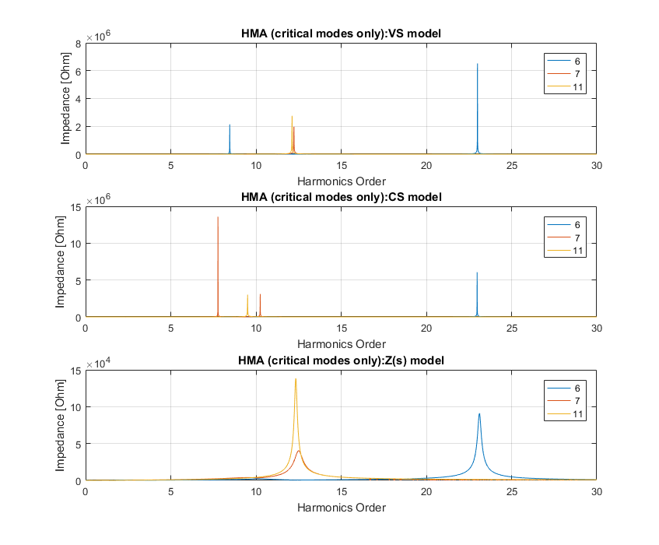

Again, the participation factors point out the connotation of each mode to the real buses in the network. Tables XX-XX presents the participation factors for the detected resonant frequencies i.e. frequencies at which the modal impedance rises occur. The values of critical impedances are gathered in Tables XX-XX.

|  |  |  |  |
| --- | --- | --- | --- |
| Order | Critical mode | Critical impedance  magnitude [Ω] | Angle  [⁰] |
| **VS model** | | | |
| 8.46 | 6 | 2140 k | -86.7 |
| 12.12 | 11 | 2753 k | 82.4 |
| 12.23 | 7 | 1965 k | 83.0 |
| 23 | 6 | 6517 k | 20.3 |
| **CS-WT model** | | | |
| 7.77 | 7 | 13.6 M | 10.6 |
| 9.51 | 11 | 3008 k | 76.8 |
| 10.25 | 7 | 3098 k | 74.2 |
| 22.98 | 6 | 6062 k | -28.5 |
| **Z(s) model** | | | |
| 9.51 | 7 | 4 k | -52.3 |
| 12.34 | 11 | 138 k | 3.3 |
| 23.11 | 6 | 91 k | -1.5 |

|  |  |  |  |  |  |  |  |  |  |  |  |  |
| --- | --- | --- | --- | --- | --- | --- | --- | --- | --- | --- | --- | --- |
| Order | Participation factors [%] for the buses | | | | | | | | | | | PF’s sum |
| 1 | 2 | 3 | 4 | 5 | 6 | 7 | 8 | 9 | 10 | 11 |
| **VS-model** | | | | | | | | | | | | |
| 8.46 | 5.3 | 7.9 | 8.0 | 8.7 | 9.0 | 9.2 | **12.5** | 8.7 | 9.0 | 9.2 | **12.5** | 1.000 |
| 12.12 | 0.0 | 0.0 | 0.0 | 0.2 | 0.3 | 1.1 | **48.4** | 0.2 | 0.3 | 1.1 | **48.4** | 1.000 |
| 12.23 | 0.3 | 0.0 | 0.0 | 0.0 | 0.1 | 0.8 | **48.9** | 0.0 | 0.1 | 0.8 | **48.9** | 1.000 |
| 23 | 0.6 | 8.9 | 9.6 | 13.6 | **14.2** | 11.7 | 1.0 | 13.6 | **14.2** | 11.7 | 1.0 | 1.000 |
| **CS-WT model** | | | | | | | | | | | | |
| 7.77 | 1.7 | 3.2 | 3.2 | 4.2 | 4.6 | 5.8 | **31.3** | 4.2 | 4.6 | 5.8 | **31.3** | 1.000 |
| 9.51 | 0.0 | 0.0 | 0.0 | 0.1 | 0.3 | 1.1 | **48.5** | 0.1 | 0.3 | 1.1 | **48.5** | 1.000 |
| 10.25 | 1.5 | 1.1 | 1.1 | 0.4 | 0.2 | 0.0 | **47.4** | 0.4 | 0.2 | 0.0 | **47.4** | 1.000 |
| 22.98 | 0.6 | 8.9 | 9.6 | 13.7 | **14.3** | 11.8 | 0.7 | 13.7 | **14.3** | 11.8 | 0.7 | 1.000 |
| **Z(s) model** | | | | | | | | | | | | |
| 9.51 | 2.8 | 5.4 | 5.5 | 7.1 | 7.8 | 9.3 | **45.5** | 7.1 | 7.8 | 9.3 | **45.5** | 1.533 |
| 12.34 | 0.0 | 0.0 | 0.0 | 0.2 | 0.3 | 1.1 | **48.4** | 0.2 | 0.3 | 1.1 | **48.4** | 1.000 |
| 23.11 | 0.7 | 8.8 | 9.5 | 13.6 | **14.2** | 11.7 | 1.0 | 13.6 | **14.2** | 11.7 | 1.0 | 1.000 |

This time we observe one significant difference between the frequency sweep curves and HRMA curves. For Z(s) model, one of the frequency missing in the frequency sweep method appears in the HRMA curves. To investigate and interpret this we look at the value of the modal impedance for this resonant frequency or at the figures. The value of critical impedance of critical module is much smaller than the other modal critical impedances (for other resonant frequencies). Since the resonant frequencies are recognized as the extreme points of impedance curves, peak value are identified in this way. However, in order to exclude this frequency from the results, further investigation of minimum dangerous impedance is necessary.

Besides this difference, the results of frequencies converge completely.

From the values of participation factors we derive couple of conclusions. First of all, the values of participation factors for buses of branch 1 (4-7) correspond to the buses of branch 2 (8-11) with the same values. That shows that from the modal analysis point of view the wind turbine branches are the same and the participation factor is distributed to the two analogical buses for both branches.

Secondly, comparing the results of participation factors for Case 1 and Case 2 we can observe some similarities in apparition of the new resonant frequency. For both VS and   
CS-WT model, the lowest resonant frequency stays approximately at the same level, to be more precise is slightly shifted down to the lower value. The value of participation factor is divided equally into two analogical buses. The second frequency from Case 1 seems to appear in Case 2 as two resonant frequencies, one greater and the other less than the frequency from Case 1. The values of participation factors for both cases for these frequencies appear to confirm this assumption since their value is again distributed equally and the values are very similar for the new two frequencies.

On the contrary, in the Z(s) model, the two frequencies stay at approximately the same level and the new resonance frequency appears “independently” after adding new branch.

Analysing the third model – Z(s) – we have to have in mind the new resonant frequency which appears in this analysis. As stated before, the value of critical impedance is very low. From the curves of modal impedances with regards to each single node, we observe that the values of two modes are at the similar level of modal impedance for this value of resonance – mode 7 and mode 11. This condition disturbs the assumption settled in Section XX that one within the modal impedances is much greater than the others. As the result, we obtain inaccurate participation factors. The easiest way to check if the that assumption is fulfilled is to sum all the participation factors for particular frequency. If the results is around 1 the assumption is achieved. For the new frequency, the sum of participation factors reaches 1.533 therefore all participation factors are is considered as inaccurate.

### DIgSILENT Power Factory “Frequency sweep” analysis

Furthermore, the results of FS and HRMA are compared with the curves acquired from Power Factory software. Figure XX presents the scheme of the network used for calculation.

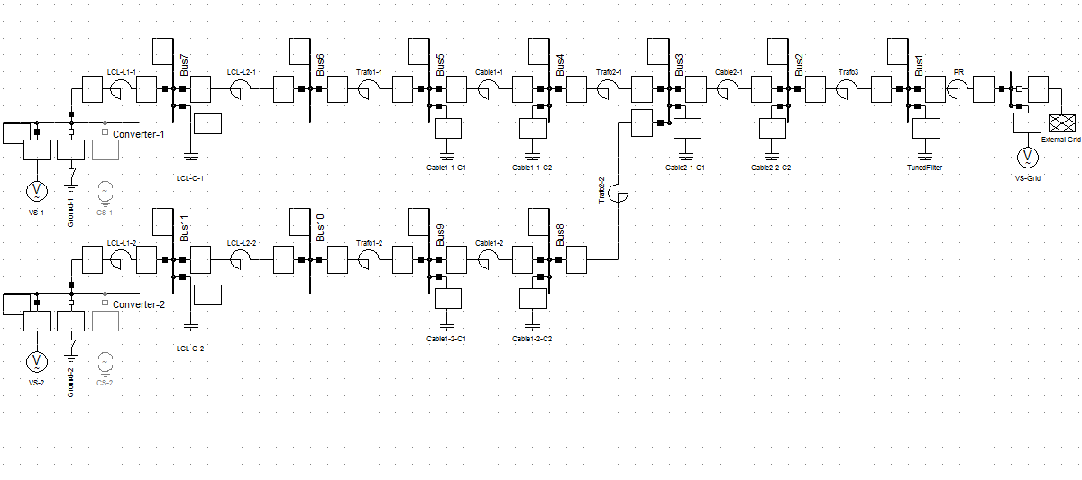Again, the models of VS and CS-WT are simulated for Impedance Frequency Characteristic calculations. Figures XX and XX present the results of frequency sweep for VS and CS-WT model, seen from the middle LCL filter bus i.e. the same bus as for MATLAB model – bus 7.

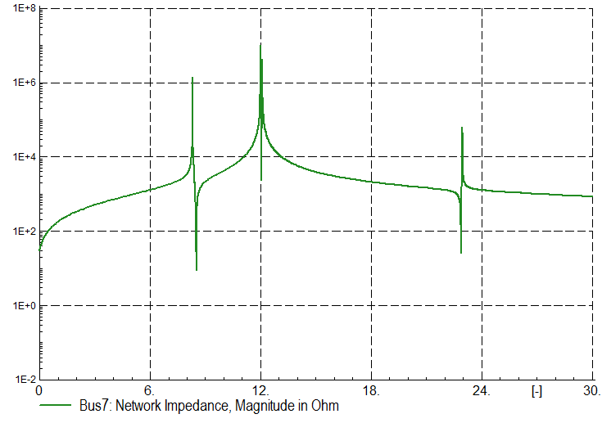

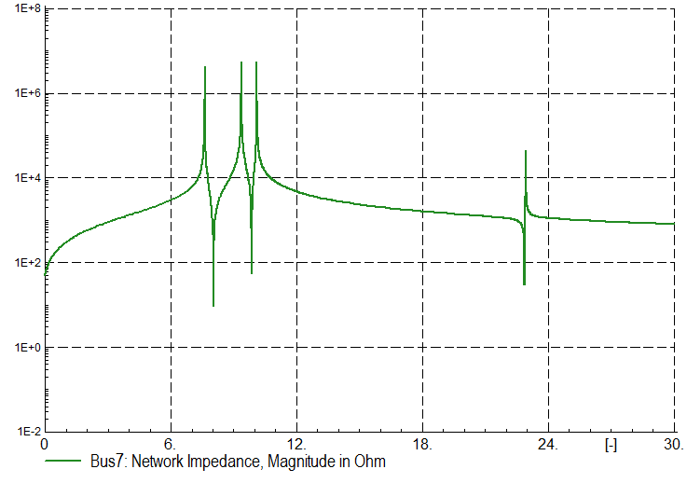

The resonant frequencies for peak impedances are measured in the software tool and presented in the Table XX:

|  |  |  |  |  |
| --- | --- | --- | --- | --- |
| Order [-] | | | | |
| VS model | 8.46 | 12.12 | 12.23 | 23.00 |
| CS-WT model | 7.77 | 9.51 | 10.25 | 22.98 |

The values of resonant frequencies are consistent with the values obtained both in FS and HRMA in MATLAB. Again, we present the impedance curves seen from other buses. The buses where the impedance is observed are buses 1-7. Since the two branches with wind turbines are the same, we know that the impedance curves seen from buses 4-7 are the same as seen from respective buses 8-11. Therefore the presentation of impedance curves for one branch is sufficient. The Figure XX shows the curves for buses 1-7 for the VS model, while the Figure XX illustrate the same curves but for model CS-WT.

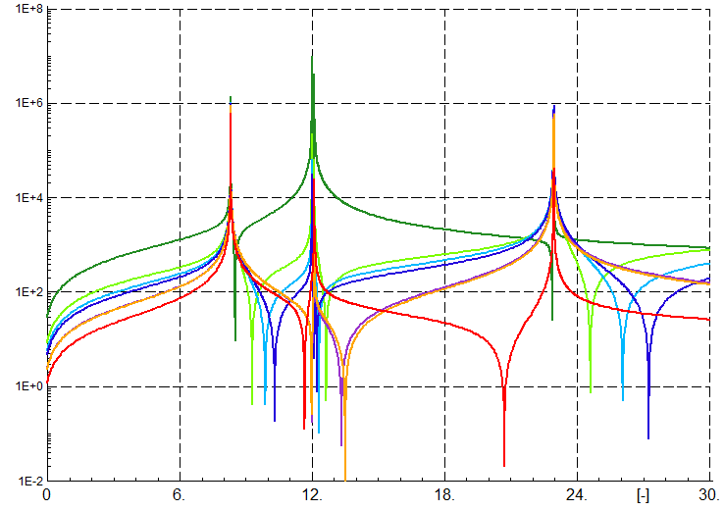



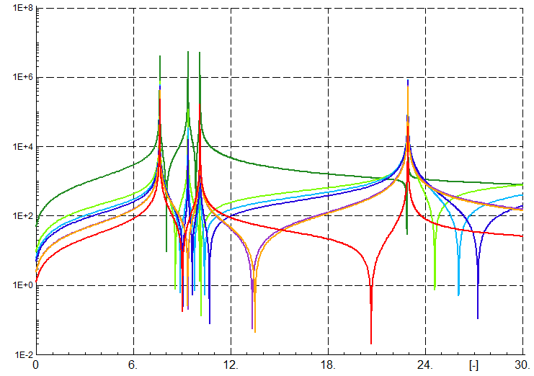

The shapes of the curves indicate the same conclusions like for Case 1 i.e. the series and parallel resonance does and does not depend on the point in the network, respectively. The previous section presenting results of Case 1 describes these principles in details. In both cases, also the series resonant frequency is shifted to the lower level each time the bus of observation is shifted to a bus with higher number i.e. bus closer to the aggregated wind turbine. However there are some exceptions.

### Results comparison

Similarly to the first case, the results of FS, HRMA and from Power Factory are very similar. For the considered accuracy, the values of corresponding frequencies are the same. The important fact to highlight is that we obtain one resonance frequency more for HRMA comparing to FS in the Z(s) model. Even though the value of modal impedance is quite low comparing to the other resonance points, the level of impedance dangerous for the network is not identified and could apparently be already dangerous in this range of frequency. The situation suggests the conclusion that we should always consider both methods together and compare their outputs. Since the amount of data necessary for both methods is very similar, this does not pose a problem.

## Case 3

The last topology case is described in Section XX. All installed power (400 MW) and all elements of Wind Power Plant are considered.

### Frequency Sweep

Figures XX and XX present the frequency sweep curves for linear and logarithmic scales, respectively. All three models are included. The bus of observation is again bus 7. All four wind turbine branches are equal therefore the features of those branches are symmetrical to each other. The groups of equal bus numbers at the wind turbine branches are: (4, 8, 13, 17), (5, 9, 14, 18), (6, 10, 15, 19), (7, 11, 16, 20). Moreover bus 3 and bus 12 are also symmetrical, installed at the end of two symmetrical cables connecting pairs of wind turbine branches.

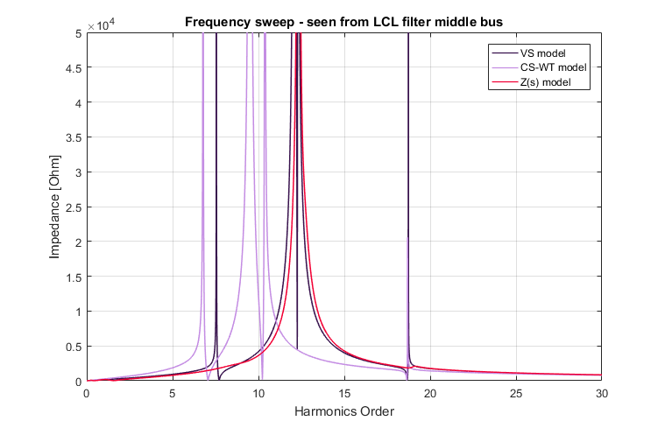

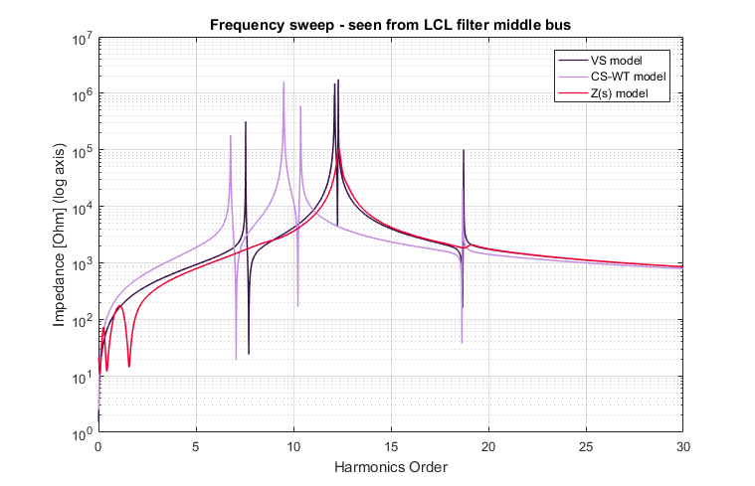

Table XX presents approximate resonance frequency values and the peak values of corresponding peaking impedance. The values around the fundamental frequency for Z(s) model are ignored.

|  |  |  |
| --- | --- | --- |
| Converter model | Frequency order [-] | Peak impedance [Ω] |
| VS | 7.55 | 318 k |
| 12.1 | 941 k |
| 12.12 | 1491 k |
| 12.3 | 1769 k |
| 18.73 | 102 k |
| CS-WT | 6.78 | 180 k |
| 9.49 | 1288 k |
| 9.51 | 1606 k |
| 10.37 | 595 k |
| 18.68 | 21 k |
| Z(s) | 12.33 | 104 k |
| 19.13 | 2 k |

We can observe one additional resonance frequency for each of the VS and CS-WT models. However, pair of frequencies for each model have very similar values therefore can be considered as the one resonant frequency. Further examination and comparison of the frequency sweep results for all considered topology cases is presented in separate Section XX.

### Harmonic Resonance Modal Analysis

Following Figures XX, XX and XX shows the HRMA results. Again, the graphs present maximum modal impedances, modal impedances curves for all modes separately and critical modes curves alone.

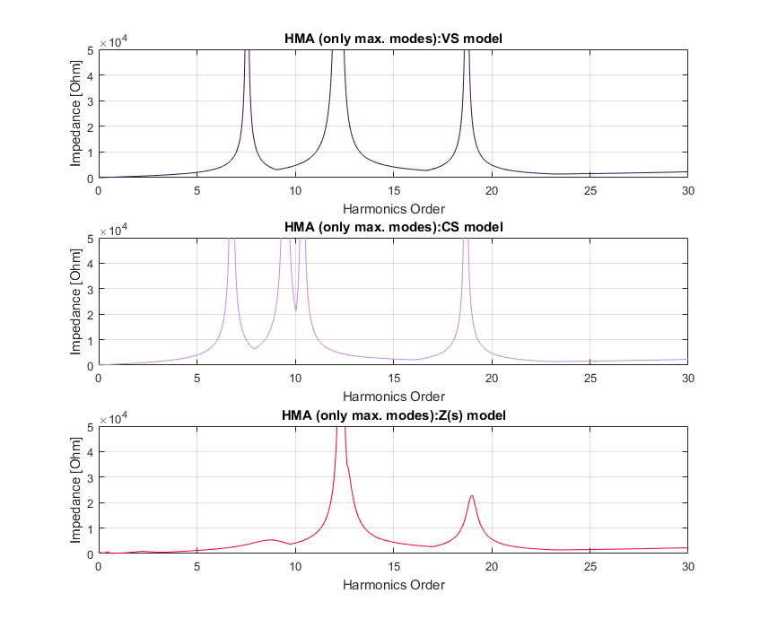

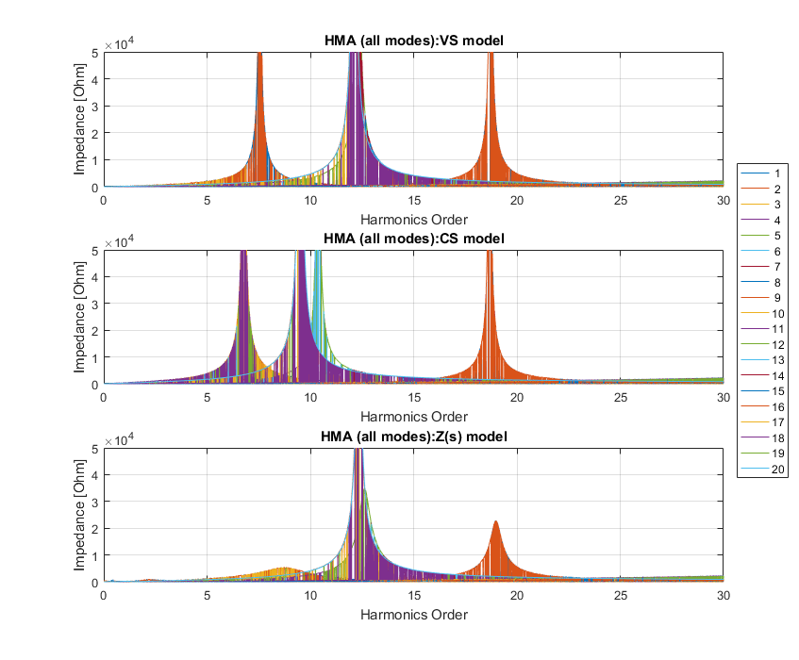

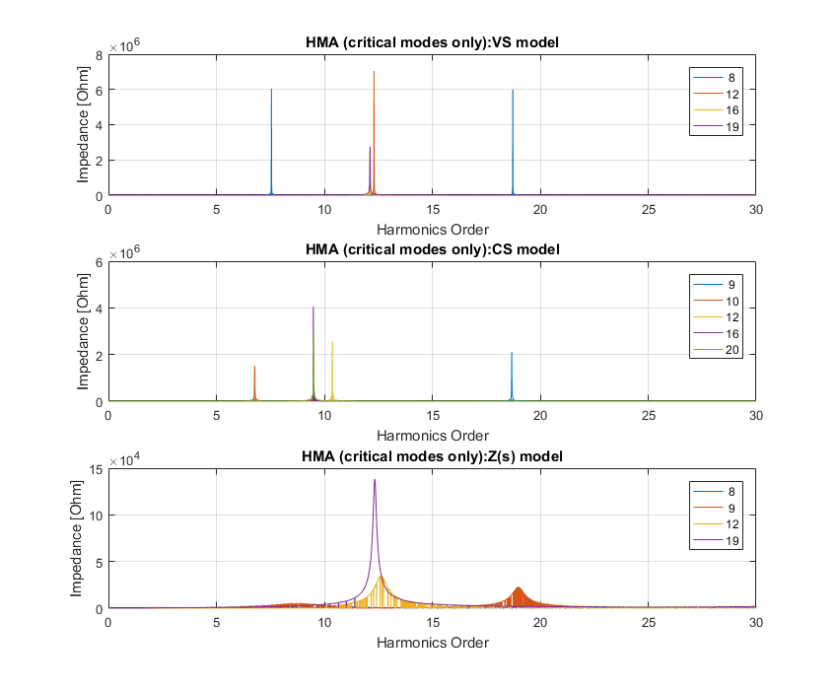

With these results in mind, the values of critical impedances and values of participation factors for Case 3 are presented for each resonance frequency in tables XX-XX and XX-XX, respectively.

|  |  |  |  |
| --- | --- | --- | --- |
| Order | Critical mode | Critical impedance  magnitude [Ω] | Angle  [⁰] |
| **VS model** | | | |
| 7.55 | 8 | 6050 k | -83.4 |
| 12.1 | 16 | 2484 k | -80.8 |
| 12.12 | 19 | 2753 k | 82.4 |
| 12.3 | 12 | 7050 k | 64.5 |
| 18.73 | 8 | 5997 k | 57.5 |
| **CS-WT model** | | | |
| 6.78 | 10 | 1511 k | 85.4 |
| 9.49 | 16 | 4054 k | -66.1 |
| 9.51 | 20 | 3008 k | 76.8 |
| 10.37 | 12 | 2567 k | -77.3 |
| 18.68 | 9 | 2114 k | -78.7 |
| **Z(s) model** | | | |
| 8.73 | 9 | 5 k | -13.6 |
| 12.34 | 19 | 138 k | 3.3 |
| 18.98 | 9 | 23 k | 4.0 |

|  |  |  |  |  |  |  |  |  |  |  |
| --- | --- | --- | --- | --- | --- | --- | --- | --- | --- | --- |
| Order | Participation factors [%] for the buses | | | | | | | | | |
| 1 | 2 | 3 | 4 | 5 | 6 | 7 | 8 | 9 | 10 |
| **VS-model** | | | | | | | | | | |
| 7.55 | 2.5 | 4.8 | 4.9 | 5.1 | 5.2 | 5.2 | **5.2** | 5.1 | 5.2 | 5.2 |
| 12.1 | 0.0 | 0.0 | 0.0 | 0.1 | 0.2 | 0.6 | **24.2** | 0.1 | 0.2 | 0.6 |
| 12.12 | 0.0 | 0.0 | 0.0 | 0.2 | 0.3 | 1.1 | **49.5** | 0.2 | 0.3 | 1.1 |
| 12.3 | 0.4 | 0.1 | 0.1 | 0.0 | 0.0 | 0.3 | **24.5** | 0.0 | 0.0 | 0.3 |
| 18.73 | 1.7 | 5.6 | 5.8 | **6.7** | 6.7 | 5.2 | 1.7 | **6.7** | 6.7 | 5.2 |
|  | 11 | 12 | 13 | 14 | 15 | 16 | 17 | 18 | 19 | 20 | PF’s sum |
| 7.55 | **5.2** | 4.9 | 5.1 | 5.2 | 5.2 | **5.2** | 5.1 | 5.2 | 5.2 | **5.2** | 1.000 |
| 12.1 | **24.2** | 0.0 | 0.1 | 0.2 | 0.6 | **24.2** | 0.1 | 0.2 | 0.6 | **24.2** | 1.000 |
| 12.12 | **49.5** | 0.0 | 0.0 | 0.0 | 0.0 | 1.9 | 0.0 | 0.0 | 0.0 | 1.9 | 1.063 |
| 12.3 | **24.5** | 0.1 | 0.0 | 0.0 | 0.3 | **24.5** | 0.0 | 0.0 | 0.3 | **24.5** | 1.000 |
| 18.73 | 1.7 | 5.8 | **6.7** | 6.7 | 5.2 | 1.7 | **6.7** | 6.7 | 5.2 | 1.7 | 1.000 |
| **CS-WT model** | | | | | | | | | | |
| 6.78 | 1.2 | 2.8 | 2.8 | 3.2 | 3.4 | 3.9 | **12.1** | 3.2 | 3.4 | 3.9 |
| 9.49 | 0.0 | 0.0 | 0.0 | 0.1 | 0.2 | 0.5 | **24.2** | 0.1 | 0.2 | 0.5 |
| 9.51 | 0.0 | 0.0 | 0.0 | 0.0 | 0.0 | 0.1 | 4.3 | 0.0 | 0.0 | 0.1 |
| 10.37 | 1.1 | 0.8 | 0.8 | 0.4 | 0.2 | 0.0 | **23.6** | 0.4 | 0.2 | 0.0 |
| 18.68 | 1.8 | 5.6 | 5.9 | **6.8** | 6.8 | 5.5 | 1.0 | **6.8** | 6.8 | 5.5 |
|  | 11 | 12 | 13 | 14 | 15 | 16 | 17 | 18 | 19 | 20 | PF’s sum |
| 6.78 | **12.1** | 2.8 | 3.2 | 3.4 | 3.9 | **12.1** | 3.2 | 3.4 | 3.9 | **12.1** | 1.000 |
| 9.49 | **24.2** | 0.0 | 0.1 | 0.2 | 0.5 | **24.2** | 0.1 | 0.2 | 0.5 | **24.2** | 1.000 |
| 9.51 | 4.3 | 0.0 | 0.1 | 0.3 | 1.0 | **44.4** | 0.1 | 0.3 | 1.0 | **44.4** | 1.005 |
| 10.37 | **23.6** | 0.8 | 0.4 | 0.2 | 0.0 | **23.6** | 0.4 | 0.2 | 0.0 | **23.6** | 1.000 |
| 18.68 | 1.0 | 5.9 | **6.8** | 6.8 | 5.5 | 1.0 | **6.8** | 6.8 | 5.5 | 1.0 | 1.000 |
| **Z(s) model** | | | | | | | | | | |
| 8.73 | 1.9 | 4.7 | 4.7 | 5.2 | 5.3 | 5.4 | **7.3** | 5.2 | 5.3 | 5.4 |
| 12.34 | 0.0 | 0.0 | 0.0 | 0.1 | 0.3 | 1.1 | **47.9** | 0.1 | 0.3 | 1.1 |
| 18.98 | 2.0 | 5.5 | 5.8 | **6.7** | 6.7 | 5.3 | 1.6 | **6.7** | 6.7 | 5.3 |
|  | 11 | 12 | 13 | 14 | 15 | 16 | 17 | 18 | 19 | 20 | PF’s sum |
| 8.73 | **7.3** | 4.7 | 5.2 | 5.3 | 5.4 | **7.3** | 5.2 | 5.3 | 5.4 | **7.3** | 1.089 |
| 12.34 | **47.9** | 0.0 | 0.0 | 0.0 | 0.0 | 1.2 | 0.0 | 0.0 | 0.0 | 1.2 | 1.012 |
| 18.98 | 1.6 | 5.8 | **6.7** | 6.7 | 5.3 | 1.6 | **6.7** | 6.7 | 5.3 | 1.6 | 1.002 |

Similarly to the Case 2, for Z(s) model we obtain one more resonance frequency from HRMA comparing to frequency sweep. Besides this frequency, the values of equivalent ones are the same or very similar. Again, the modal impedance value of critical mode for new frequency is very low.

Furthermore, the participation factors for new frequency are probably inaccurate since the sum of them for the new frequency exceeds unity. Finally, we note that the participation factors are not completely symmetrical in some cases. The symmetry remains between the pair of branches 1 and 2 or 3 and 4 (the pairs connected to the same three-winding transformer) but symmetry of participation factors between pair branches connected to different three-winding transformers fades away.

### DIgSILENT Power Factory “Frequency sweep” analysis

Analogically, we compare the results of FS and HRMA with the curves from Power Factory model. The model used in this case is presented in the Figure XX.

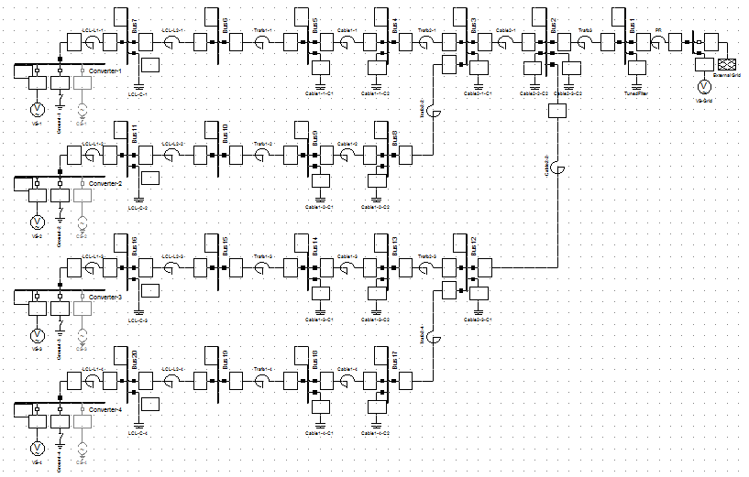

The models of VS and CS-WT are simulated for Impedance Frequency Characteristic calculations. Figures XX and XX present the results of frequency sweep for VS and CS-WT model, seen from the middle LCL filter bus i.e. the same bus as for MATLAB model – bus 7.

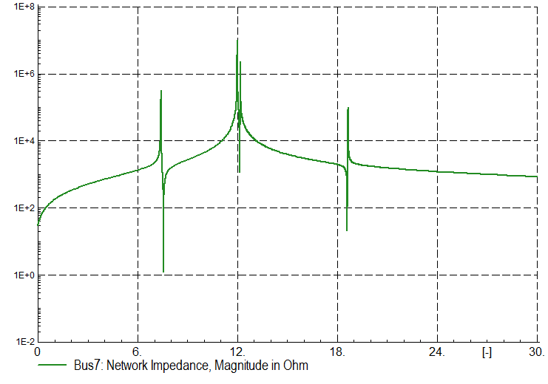

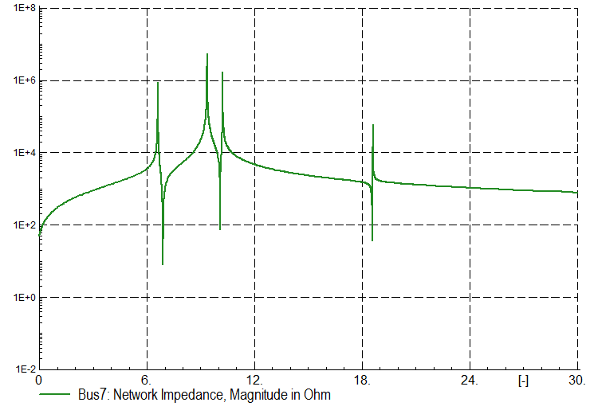

The resonant frequencies for peak impedances are measured in the software tool and presented in the Table XX:

|  |  |  |  |  |  |
| --- | --- | --- | --- | --- | --- |
| Order [-] | | | | | |
| VS model | 7.55 | 12.10 | 12.12 | 12.30 | 18.73 |
| CS-WT model | 6.78 | 9.49 | 9.51 | 10.37 | 18.68 |

One more time, the values obtained from Power Factory converge with those we collected from frequency sweep analysis in MATLAB. Similarly to the Case 2 analysis, the Figures XX and XX show the curves for buses 1-7 for the VS model and CS-WT model, respectively.

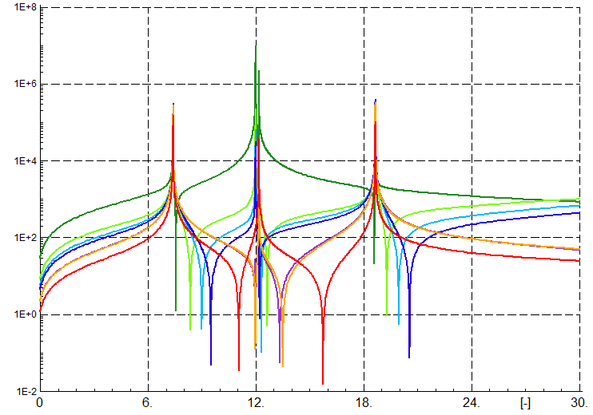



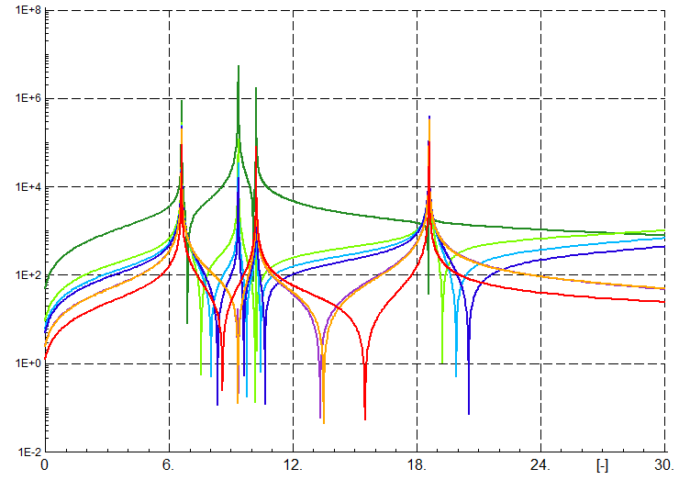

The shapes of the curves indicate the similar conclusions like for Case 1 and Case 2.

### Results comparison

Similarly to the first and second case, the values of received frequencies from all three approaches are similar. Once again, we obtain one more resonant frequency from HRMA comparing to frequency sweep. Again we observe similar behavior of resonances with regard to the bus of observation.

## Comparison between topology cases

In this section we compare the results obtained in three previous sections jointly. The following figures and tables demonstrate the behavior of frequency sweep curves for VS model, CS-WT model and Z(s) model. Each model is considered separately but for all three topology cases jointly. In tables the results of resonance frequencies for all topology cases (parallel resonance) are gathered. The aim of this section is to identify patterns and any similarities between the topology cases and the models.

### VS model

#### Frequency sweep

The following figure presents the frequency sweep curves for all three topology cases. We had a try to group the frequencies in the three groups like indicated in the figure.

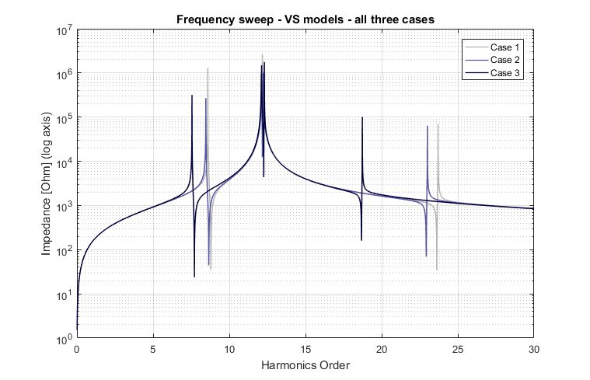

|  |  |  |  |
| --- | --- | --- | --- |
| Method / model | Frequency order [-] | | |
| FS / VS | **Case 1** | **Case 2** | **Case 3** |
| 8.59 | 8.46 | 7.55 |
| 12.17 | 12.12 | 12.1 |
|  | 12.23 | 12.12 |
|  |  | 12.3 |
| 23.7 | 23.00 | 18.73 |

We observe clearly that that in each next case, the frequencies of first and third group are shifted downward. The second group (around 12th harmonic order) is becoming more numerous for the cases with multiple branches, whereas the values stay at the similar level.

#### Harmonic Resonance Modal Analysis

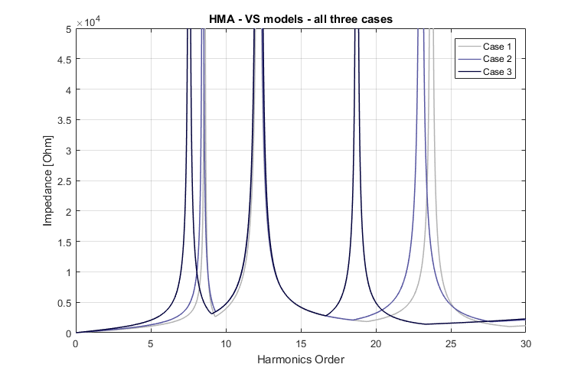

Since the frequencies calculated in HRMA are the same to those obtained from frequency sweep, we do not draw more observations. However, we also have at our disposal the values of participation factors indicating the excitability and observability of the buses in the network. The values of PF’s for three topology cases for VS mode are gathered in the tables XX-XX.

|  |  |  |  |  |  |  |  |  |
| --- | --- | --- | --- | --- | --- | --- | --- | --- |
| Frequency order [-] | Participation factors [%] for the buses | | | | | | | |
| **Case 1** | | | | | | | |
| 1 | 2 | 3 | 4 | 5 | 6 | 7 | PF’s sum |
| 8.59 | 8.8 | 12.8 | 13.0 | 14.2 | 14.6 | 15.1 | **21.5** | 1.000 |
| 12.17 | 0.1 | 0.0 | 0.0 | 0.2 | 0.4 | 1.8 | **97.4** | 1.000 |
| 23.7 | 0.9 | 14.6 | 15.7 | **23.1** | **24.3** | 20.0 | 1.4 | 1.000 |

|  |  |  |  |  |  |  |  |  |  |  |  |  |
| --- | --- | --- | --- | --- | --- | --- | --- | --- | --- | --- | --- | --- |
| Frequency order [-] | Participation factors [%] for the buses | | | | | | | | | | | |
| **Case 2** | | | | | | | | | | | |
| 1 | 2 | 3 | 4 | 5 | 6 | 7 | 8 | 9 | 10 | 11 | PF’s sum |
| 8.46 | 5.3 | 7.9 | 8.0 | 8.7 | 9.0 | 9.2 | **12.5** | 8.7 | 9.0 | 9.2 | **12.5** | 1.000 |
| 12.12 | 0.0 | 0.0 | 0.0 | 0.2 | 0.3 | 1.1 | **48.4** | 0.2 | 0.3 | 1.1 | **48.4** | 1.000 |
| 12.23 | 0.3 | 0.0 | 0.0 | 0.0 | 0.1 | 0.8 | **48.9** | 0.0 | 0.1 | 0.8 | **48.9** | 1.000 |
| 23 | 0.6 | 8.9 | 9.6 | **13.6** | **14.2** | 11.7 | 1.0 | **13.6** | **14.2** | 11.7 | 1.0 | 1.000 |

|  |  |  |  |  |  |  |  |  |  |  |
| --- | --- | --- | --- | --- | --- | --- | --- | --- | --- | --- |
| Frequency order [-] | Participation factors [%] for the buses | | | | | | | | | |
| **Case 3** | | | | | | | | | |
| 1 | 2 | 3 | 4 | 5 | 6 | 7 | 8 | 9 | 10 |
| 7.55 | 2.5 | 4.8 | 4.9 | 5.1 | 5.2 | 5.2 | **5.2** | 5.1 | 5.2 | 5.2 |
| 12.1 | 0.0 | 0.0 | 0.0 | 0.1 | 0.2 | 0.6 | **24.2** | 0.1 | 0.2 | 0.6 |
| 12.12 | 0.0 | 0.0 | 0.0 | 0.2 | 0.3 | 1.1 | **49.5** | 0.2 | 0.3 | 1.1 |
| 12.3 | 0.4 | 0.1 | 0.1 | 0.0 | 0.0 | 0.3 | **24.5** | 0.0 | 0.0 | 0.3 |
| 18.73 | 1.7 | 5.6 | 5.8 | **6.7** | **6.7** | 5.2 | 1.7 | **6.7** | **6.7** | 5.2 |
|  | 11 | 12 | 13 | 14 | 15 | 16 | 17 | 18 | 19 | 20 | PF’s sum |
| 7.55 | **5.2** | 4.9 | 5.1 | 5.2 | 5.2 | **5.2** | 5.1 | 5.2 | 5.2 | **5.2** | 1.000 |
| 12.1 | **24.2** | 0.0 | 0.1 | 0.2 | 0.6 | **24.2** | 0.1 | 0.2 | 0.6 | **24.2** | 1.000 |
| 12.12 | **49.5** | 0.0 | 0.0 | 0.0 | 0.0 | 1.9 | 0.0 | 0.0 | 0.0 | 1.9 | 1.063 |
| 12.3 | **24.5** | 0.1 | 0.0 | 0.0 | 0.3 | **24.5** | 0.0 | 0.0 | 0.3 | **24.5** | 1.000 |
| 18.73 | 1.7 | 5.8 | **6.7** | **6.7** | 5.2 | 1.7 | **6.7** | **6.7** | 5.2 | 1.7 | 1.000 |

From the values of PF’s we can see the pattern that confirms our assumption created with respect to resonant frequencies from frequency sweep only. The first group of harmonics seems to mark the bus 7 (and symmetrical buses of other branches) as the source of this group of resonances. It touches all topology cases. We have to notice that the values of the PF’s could be also considered as spread quite evenly between the buses. In case of the second group of resonant frequency (around 12th harmonic order), the bus that is surely indicated by the PF’s is the bus 7 (and symmetrical ones). For the third group of resonances, we identify two buses (bus 4 and bus 5) indicated by PF’s as the two participating the most in the excitation of the resonance. Bus 4 and bus 5 are the terminals of 33 kV collection cable. The observations described above are encapsulated in the   
Table XX.

|  |  |  |  |  |
| --- | --- | --- | --- | --- |
| Method / model | Frequency order [-] | | | Dominant bus |
| HRMA / VS | **Case 1** | **Case 2** | **Case 3** |
| 8.59 | 8.46 | 7.55 | Middle LCL buses (7) or evenly |
| 12.17 | 12.12 | 12.1 | Middle LCL buses (7) |
|  | 12.23 | 12.12 |
|  |  | 12.3 |
| 23.7 | 23.00 | 18.73 | Cable 33 kV terminal buses (4, 5) |

### CS-WT model

#### Frequency sweep

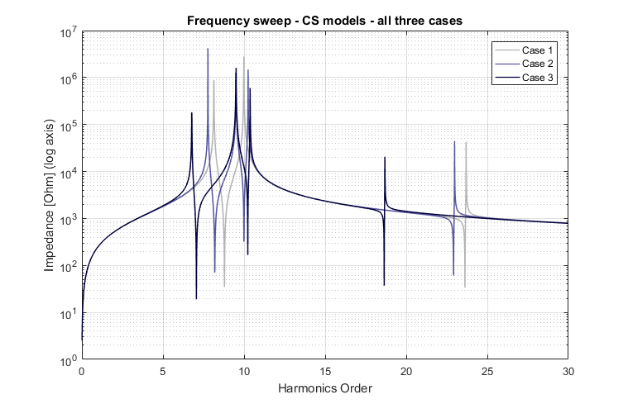

|  |  |  |  |
| --- | --- | --- | --- |
| Method / model | Frequency order [-] | | |
| FS / CS-WT | **Case 1** | **Case 2** | **Case 3** |
| 8.14 | 7.77 | 6.78 |
| 9.99 | 9.51 | 9.49 |
|  | 10.25 | 9.51 |
|  |  | 10.37 |
| 23.69 | 22.98 | 18.68 |

Similarly to the observations drawn for the Voltage Source model we can conclude for the model with aggregated WT converters modelled as Current Sources. On the basis of FS only, we divide the values of resonance frequencies into three groups. Again, we detect that the values of each group are shifted downwards when the number of branches is increased. All of the values of the frequencies are lower comparing o the first topology case. For each group, these changes differ.

#### Harmonic Resonance Modal Analysis

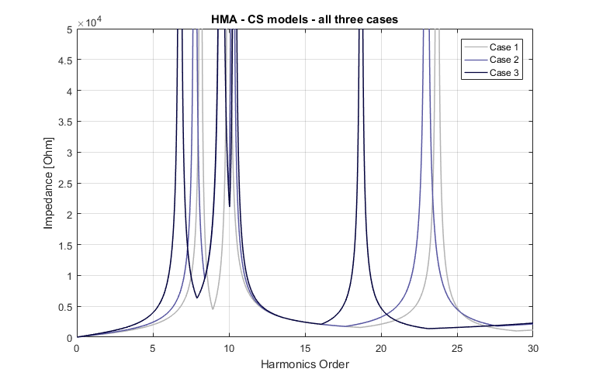

The values of frequency orders are the same for FS and HRMA. Again, we include participation factors to our conclusions and try to identify some patterns. The values of PF’s for all cases are presented first in tables XX-XX.

|  |  |  |  |  |  |  |  |  |
| --- | --- | --- | --- | --- | --- | --- | --- | --- |
| Frequency order [-] | Participation factors [%] for the buses | | | | | | | |
| **Case 1** | | | | | | | |
| 1 | 2 | 3 | 4 | 5 | 6 | 7 | PF’s sum |
| 8.14 | 2.6 | 4.4 | 4.4 | 6.2 | 7.0 | 9.3 | **66.0** | 1.000 |
| 9.99 | 1.1 | 1.0 | 0.9 | 0.2 | 0.0 | 0.3 | **96.5** | 1.000 |
| 23.69 | 0.9 | 14.6 | 15.6 | **23.2** | **24.4** | 20.2 | 1.1 | 1.000 |

|  |  |  |  |  |  |  |  |  |  |  |  |  |
| --- | --- | --- | --- | --- | --- | --- | --- | --- | --- | --- | --- | --- |
| Frequency order [-] | Participation factors [%] for the buses | | | | | | | | | | | |
| **Case 2** | | | | | | | | | | | |
| 1 | 2 | 3 | 4 | 5 | 6 | 7 | 8 | 9 | 10 | 11 | PF’s sum |
| 7.77 | 1.7 | 3.2 | 3.2 | 4.2 | 4.6 | 5.8 | **31.3** | 4.2 | 4.6 | 5.8 | **31.3** | 1.000 |
| 9.51 | 0.0 | 0.0 | 0.0 | 0.1 | 0.3 | 1.1 | **48.5** | 0.1 | 0.3 | 1.1 | **48.5** | 1.000 |
| 10.25 | 1.5 | 1.1 | 1.1 | 0.4 | 0.2 | 0.0 | **47.4** | 0.4 | 0.2 | 0.0 | **47.4** | 1.000 |
| 22.98 | 0.6 | 8.9 | 9.6 | **13.7** | **14.3** | 11.8 | 0.7 | **13.7** | **14.3** | 11.8 | 0.7 | 1.000 |

|  |  |  |  |  |  |  |  |  |  |  |
| --- | --- | --- | --- | --- | --- | --- | --- | --- | --- | --- |
| Frequency order [-] | Participation factors [%] for the buses | | | | | | | | | |
| **Case 3** | | | | | | | | | |
| 1 | 2 | 3 | 4 | 5 | 6 | 7 | 8 | 9 | 10 |
| 6.78 | 1.2 | 2.8 | 2.8 | 3.2 | 3.4 | 3.9 | **12.1** | 3.2 | 3.4 | 3.9 |
| 9.49 | 0.0 | 0.0 | 0.0 | 0.1 | 0.2 | 0.5 | **24.2** | 0.1 | 0.2 | 0.5 |
| 9.51 | 0.0 | 0.0 | 0.0 | 0.0 | 0.0 | 0.1 | 4.3 | 0.0 | 0.0 | 0.1 |
| 10.37 | 1.1 | 0.8 | 0.8 | 0.4 | 0.2 | 0.0 | **23.6** | 0.4 | 0.2 | 0.0 |
| 18.68 | 1.8 | 5.6 | 5.9 | **6.8** | **6.8** | 5.5 | 1.0 | **6.8** | **6.8** | 5.5 |
|  | 11 | 12 | 13 | 14 | 15 | 16 | 17 | 18 | 19 | 20 | PF’s sum |
| 6.78 | **12.1** | 2.8 | 3.2 | 3.4 | 3.9 | **12.1** | 3.2 | 3.4 | 3.9 | **12.1** | 1.000 |
| 9.49 | **24.2** | 0.0 | 0.1 | 0.2 | 0.5 | **24.2** | 0.1 | 0.2 | 0.5 | **24.2** | 1.000 |
| 9.51 | 4.3 | 0.0 | 0.1 | 0.3 | 1.0 | **44.4** | 0.1 | 0.3 | 1.0 | **44.4** | 1.005 |
| 10.37 | **23.6** | 0.8 | 0.4 | 0.2 | 0.0 | **23.6** | 0.4 | 0.2 | 0.0 | **23.6** | 1.000 |
| 18.68 | 1.0 | 5.9 | **6.8** | **6.8** | 5.5 | 1.0 | **6.8** | **6.8** | 5.5 | 1.0 | 1.000 |

On the basis of PF’s, we draw the similar observations for CS-WT model than from VS model. The PF’s for the first two groups of harmonic orders indicates bus 7 (and symmetrical buses at other branches) as the bus with highest participation to the harmonic excitation. In the same manner as for VS model, the PF’s of harmonic orders of third group mark the buses 4 and 5 as the buses exciting the resonance. These observations are gathered in the Table XX.

|  |  |  |  |  |
| --- | --- | --- | --- | --- |
| Method / model | Frequency order [-] | | | Dominant bus |
| HRMA / CS-WT | **Case 1** | **Case 2** | **Case 3** |
| 8.14 | 7.77 | 6.78 | Middle LCL bus (7) |
| 9.99 | 9.51 | 9.49 |
|  | 10.25 | 9.51 |
|  |  | 10.37 |
| 23.69 | 22.98 | 18.68 | Cable 33 kV terminal buses (4, 5) |

### Z(s) model

#### Frequency Sweep

Figure XX shows the FS curves for all topology cases derived for Z(s) model.

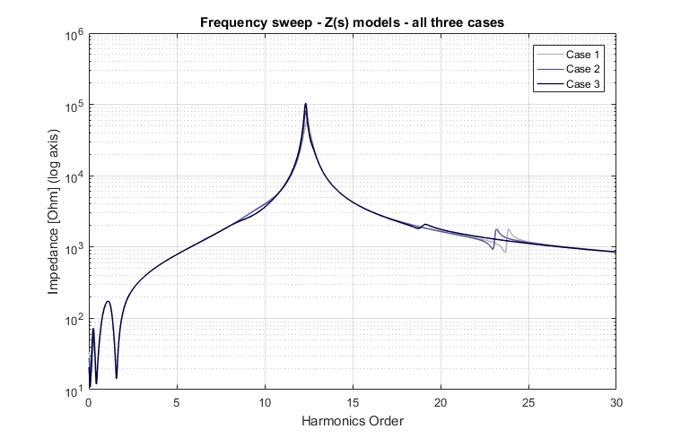

|  |  |  |  |
| --- | --- | --- | --- |
| Method / model | Frequency order [-] | | |
| FS / Z(s) | **Case 1** | **Case 2** | **Case 3** |
| 12.42 | 12.33 | 12.33 |
| 23.87 | 23.18 | 19.13 |

This time, FS method does not detect resonance frequencies analogical to the lowest orders group for VS and CS-WT model. The number of peaking impedance points around 12th order also does not increase for multiple branches cases. However, we observe the equivalent resonances for two groups with values very close to the VS model. Also, we mark the downward shift for multiple branches what was the same for the other models.

#### Harmonic Resonance Modal Analysis

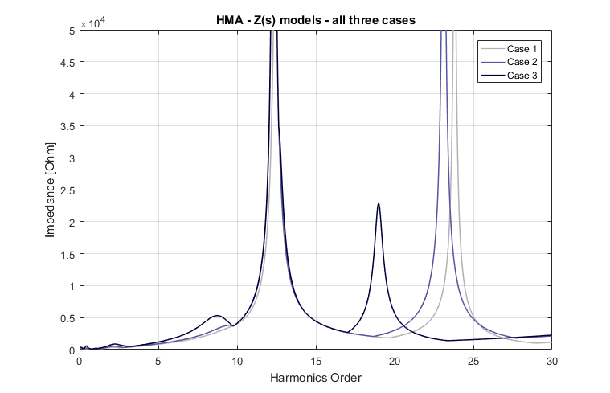

As pointed out in previous section, for Z(s) model HRMA detects additional resonant frequency comparing to FS, but at the low level (relatively to the other critical impedances). These new frequencies corresponds accurately to the first group of frequencies detected in VS and CS-WT model.

Again, we include PF’s in the analysis and we identify the buses with the highest values of PF’s. The tables XX-XX presents PF’s values for all topology cases.

|  |  |  |  |  |  |  |  |  |
| --- | --- | --- | --- | --- | --- | --- | --- | --- |
| Frequency order [-] | Participation factors [%] for the buses | | | | | | | |
| **Case 1** | | | | | | | |
| 1 | 2 | 3 | 4 | 5 | 6 | 7 | PF’s sum |
| 12.42 | 0.2 | 0.1 | 0.1 | 0.2 | 0.5 | 1.8 | **97.8** | 1.007 |
| 23.81 | 1.0 | 14.5 | 15.6 | **23.1** | **24.3** | 20.1 | 1.4 | 1.000 |

|  |  |  |  |  |  |  |  |  |  |  |  |  |
| --- | --- | --- | --- | --- | --- | --- | --- | --- | --- | --- | --- | --- |
| Frequency order [-] | Participation factors [%] for the buses | | | | | | | | | | | |
| **Case 2** | | | | | | | | | | | |
| 1 | 2 | 3 | 4 | 5 | 6 | 7 | 8 | 9 | 10 | 11 | PF’s sum |
| 9.51 | 2.8 | 5.4 | 5.5 | 7.1 | 7.8 | 9.3 | **45.5** | 7.1 | 7.8 | 9.3 | **45.5** | 1.533 |
| 12.34 | 0.0 | 0.0 | 0.0 | 0.2 | 0.3 | 1.1 | **48.4** | 0.2 | 0.3 | 1.1 | **48.4** | 1.000 |
| 23.11 | 0.7 | 8.8 | 9.5 | **13.6** | **14.2** | 11.7 | 1.0 | **13.6** | **14.2** | 11.7 | 1.0 | 1.000 |

|  |  |  |  |  |  |  |  |  |  |  |
| --- | --- | --- | --- | --- | --- | --- | --- | --- | --- | --- |
| Frequency order [-] | Participation factors [%] for the buses | | | | | | | | | |
| **Case 3** | | | | | | | | | |
| 1 | 2 | 3 | 4 | 5 | 6 | 7 | 8 | 9 | 10 |
| 8.73 | 1.9 | 4.7 | 4.7 | 5.2 | 5.3 | 5.4 | **7.3** | 5.2 | 5.3 | 5.4 |
| 12.34 | 0.0 | 0.0 | 0.0 | 0.1 | 0.3 | 1.1 | **47.9** | 0.1 | 0.3 | 1.1 |
| 18.98 | 2.0 | 5.5 | 5.8 | **6.7** | **6.7** | 5.3 | 1.6 | **6.7** | **6.7** | 5.3 |
|  | 11 | 12 | 13 | 14 | 15 | 16 | 17 | 18 | 19 | 20 | PF’s sum |
| 8.73 | **7.3** | 4.7 | 5.2 | 5.3 | 5.4 | **7.3** | 5.2 | 5.3 | 5.4 | **7.3** | 1.089 |
| 12.34 | **47.9** | 0.0 | 0.0 | 0.0 | 0.0 | 1.2 | 0.0 | 0.0 | 0.0 | 1.2 | 1.012 |
| 18.98 | 1.6 | 5.8 | **6.7** | **6.7** | 5.3 | 1.6 | **6.7** | **6.7** | 5.3 | 1.6 | 1.002 |

With respect to PF’s, we observe the very similar results to the models VS and CS-WT. The PF’s of harmonic orders of the first group and the medium one indicates bus 7 as the one participating the most in the resonances. For the highest order group, similarly, the buses 4 and 5 are identified.

|  |  |  |  |  |
| --- | --- | --- | --- | --- |
| Method / model | Frequency order [-] | | | Dominant bus |
| HRMA / Z(s) | **Case 1** | **Case 2** | **Case 3** |
|  | 9.51 | 8.73 | Middle LCL bus (7) |
| 12.42 | 12.34 | 12.34 |
| 23.81 | 23.11 | 18.98 | Cable 33 kV terminal buses (4, 5) |

## Conclusions about models

On an axis….?

# Stability study for different topology cases

This section presents the results of stability analysis for the three different already described topology cases. The principles of stability analysis are described in Section XX in the theoretical part of the thesis. In this part, only the last model of the network is used i.e. the model containing the nonlinear impedances of the converters – Z(s) model. This model is considered as the most polished within all presented in this thesis. In short, the stability is evaluated on the basis of Nyquist stability criterion plotted in the Bode diagrams. The method is considered as still under development [BorWind1??]. The question that has not been struck in the literature is the use of both WT converter nonlinear model and HVDC-link converter nonlinear model at the same time for stability study.

The sections below present the results separately for each topology case, also comparing the values obtained to the previous results from FS and HRMA methods.

## Stability of Case 1

The figure XX present the Bode diagram of the considered model used for stability study. As described in detail in theoretical part, the network is divided into two elements: the source and the grid. The point of division is behind the HV transformer, looking from the grid side. The positive and negative sequences of grid and source segments are presented in domain of frequency.

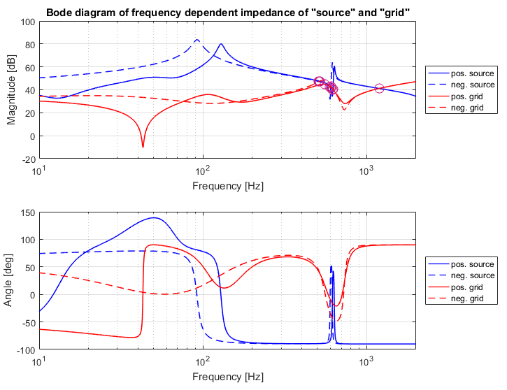

The points of attention where the instabilities may occur are the crossings of the grid and the source impedances, regardless the positive or negative sequence. All of them are investigated and the possible instabilities identified. In the figure XX the intersections are marked with purple circles. Figure XX presents the source and grid curves zoomed in the area of high density of intersections.

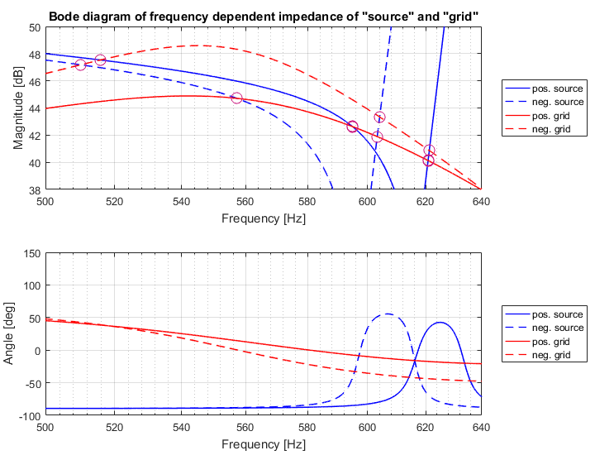

For each intersection, the values of angle depending on the difference between appropriate curves is calculated in MATLAB. Table XX presents the values of frequencies for which the crossings occur, also the values of angles indicating stability are included.

|  |  |
| --- | --- |
| Frequency order [-] |  |
| **Positive Grid – Positive Source** | |
| 11.90 | 102.61 |
| 12.42 | 130.28 |
| 23.81 | 0.64 |
| **Positive Grid – Negative Source** | |
| 11.14 | 77.25 |
| 12.07 | 117.44 |
| 23.81 | 0.64 |
| **Negative Grid –Positive Source** | |
| 10.32 | 51.66 |
| 12.43 | 101.61 |
| 23.81 | 0.18 |
| **Negative Grid – Negative Source** | |
| 10.20 | 48.01 |
| 12.08 | 89.40 |
| 23.81 | 0.18 |

## Stability of Case 2

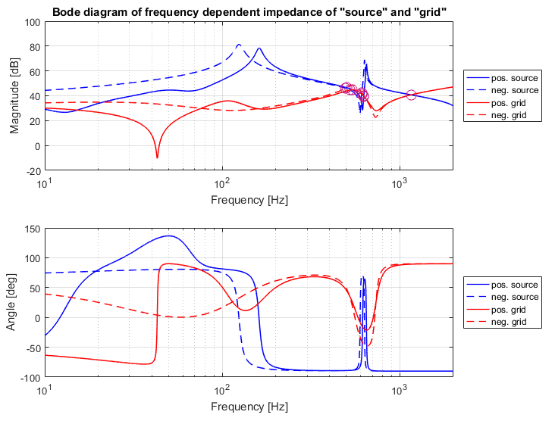

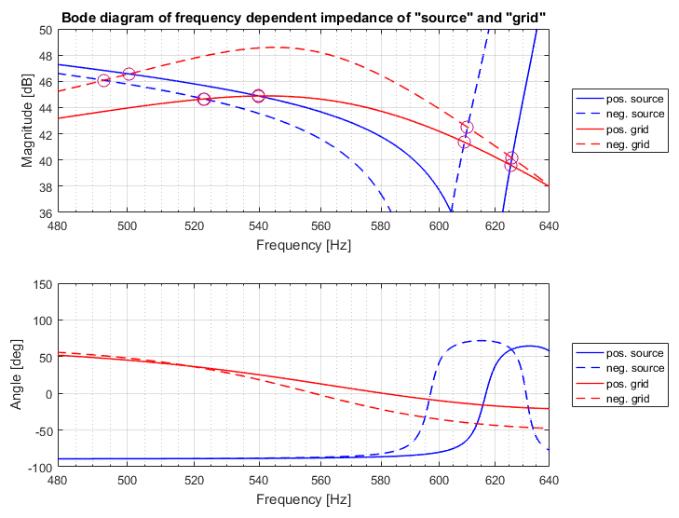

|  |  |
| --- | --- |
| Frequency order [-] |  |
| **Positive Grid – Positive Source** | |
| 10.80 | 66.03 |
| 12.51 | 102.31 |
| 23.11 | 0.78 |
| **Positive Grid – Negative Source** | |
| 10.46 | 56.37 |
| 12.18 | 96.94 |
| 23.11 | 0.78 |
| **Negative Grid –Positive Source** | |
| 10.00 | 43.12 |
| 12.52 | 74.85 |
| 23.12 | 0.26 |
| **Negative Grid – Negative Source** | |
| 9.86 | 39.72 |
| 12.20 | 69.60 |
| 23.12 | 0.24 |

## Stability of Case 3

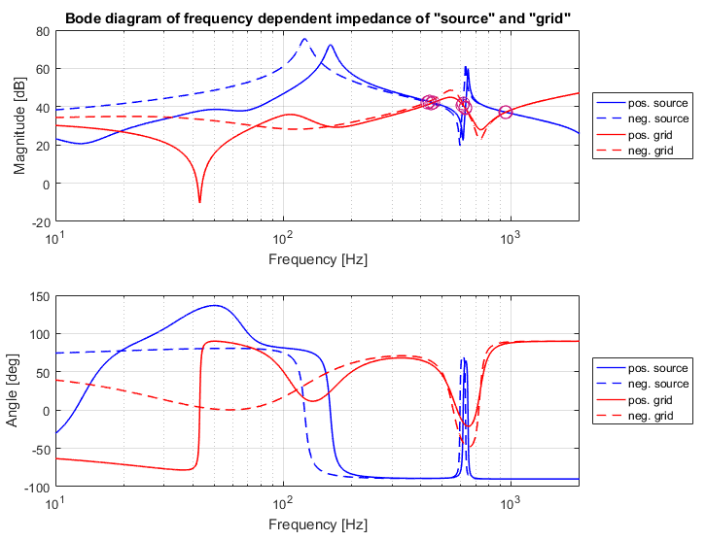

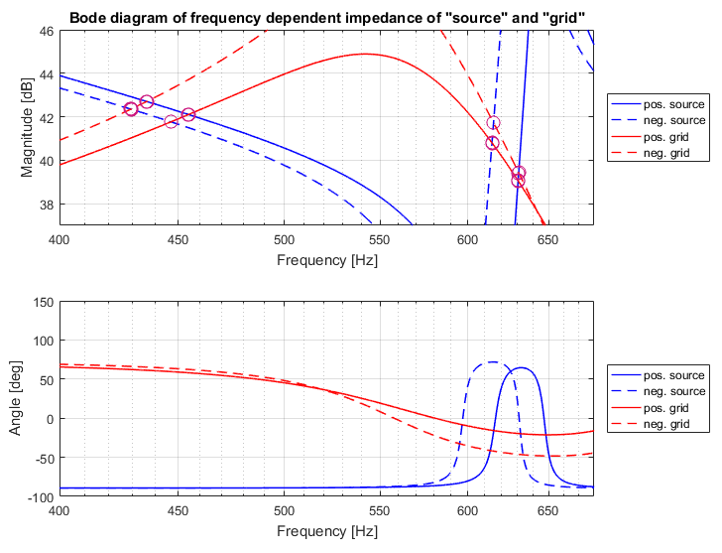

|  |  |
| --- | --- |
| Frequency order [-] |  |
| **Positive Grid – Positive Source** | |
| 9.09 | 32.71 |
| 12.61 | 96.31 |
| 18.96 | 3.28 |
| **Positive Grid – Negative Source** | |
| 8.94 | 31.14 |
| 12.29 | 92.7 |
| 18.95 | 3.29 |
| **Negative Grid –Positive Source** | |
| 8.72 | 25.45 |
| 12.62 | 69.49 |
| 18.99 | 1.29 |
| **Negative Grid – Negative Source** | |
| 8.59 | 24.47 |
| 12.31 | 66.09 |
| 18.99 | 1.29 |

## Comparison to FS and HRMA and conclusions

|  |  |  |  |
| --- | --- | --- | --- |
| Method / model | Frequency order [-] | | |
| FS / Z(s) | **Case 1** | **Case 2** | **Case 3** |
| 12.42 | 12.33 | 12.33 |
| 23.87 | 23.18 | 19.13 |

|  |  |  |  |  |
| --- | --- | --- | --- | --- |
| Method / model | Frequency order [-] | | | Dominant bus |
| HRMA / Z(s) | **Case 1** | **Case 2** | **Case 3** |
|  | 9.51 | 8.73 | Middle LCL bus (7) |
| 12.42 | 12.34 | 12.34 |
| 23.81 | 23.11 | 18.98 | Cable 33 kV terminal buses (4, 5) |

|  |  |  |  |
| --- | --- | --- | --- |
| Method / model | Frequency order [-] | | |
| **Case 1** | **Case 2** | **Case 3** |
| Bode / Z(s) | 11.90 | 10.80 | 9.09 |
| 11.14 | 10.46 | 8.94 |
| 10.32 | 10.00 | 8.72 |
| 10.20 | 9.86 | 8.59 |
| 12.42 | 12.51 | 12.61 |
| 12.07 | 12.18 | 12.29 |
| 12.43 | 12.52 | 12.62 |
| 12.08 | 12.20 | 12.31 |
| 23.81 | 23.11 | 18.96 |
| 23.81 | 23.11 | 18.95 |
| 23.81 | 23.12 | 18.99 |
| 23.81 | 23.12 | 18.99 |

|  |  |  |  |
| --- | --- | --- | --- |
| Method / model | Frequency order [-] | | |
| **Case 1** | **Case 2** | **Case 3** |
| Bode / Z(s) | 10.20 - 11.90 | 9.86 - 10.80 | 8.59 - 9.09 |
| 12.07 - 12.42 | 12.18 - 12.52 | 12.29 - 12.62 |
| 23.81 | 23.11 – 23.12 | 18.96 -18.99 |

III. References

R. Bellman, Introduction to Matrix Analysis, 2nd ed. New York: Mc-Graw-Hill, 1970.

I. J. Perez-Arriaga, G. C. Verghese, and F. C. Schweppe, “Selective

modal analysis with applications to electric power systems—I. Heuristic

introduction,” IEEE Trans. Power App. Syst., vol. PAS-101, no. 9, pp.

3117–3125, Sep. 1982.

R. D. Middlebrook, “Input filter considerations in design and application

of switching regulators,” in Rec.1976 IEEE Ind. Appl. Soc. Annu. Meeting,

pp. 366–382.

Z. Bing, K. J. Karimi, and J. Sun, “Input impedance modeling and

analysis of line-commutated rectifiers,” IEEE Trans. Power Electron.,

vol. 24, no. 10, pp. 2338–2346, Oct. 2009.

M. Cespedes and J. Sun, “Impedance modeling and analysis of gridconnected

voltage-source converters,” IEEE Trans. Power Electron.,

vol. 29, no. 3, pp. 1254–1261, Mar. 2014.

E. Larsen, G. Drobnjak, and H. Elahi, “Standardization of VSC-HVdc

interface with offshore wind generation,” in Proc. 11th Int. Workshop

Large-Scale Integr. Wind Power Power Syst., Nov. 2012. pp. 169–174

# Abbreviations

WPP – wind power plant

HVDC – high voltage direct current

CS – current source

VS – voltage source

AC – alternating current

FS – frequency sweep

HRMA – harmonic resonance modal analysis

GTO, IGBT, MTO

VSI – voltage source inverter

PWM – pulse width modulation

PCC – point of common coupling

WF – wind farm

EMT – electromagnetic transient

IEC – International Electrotechnical Commission

IEEE

SCIG – squirrel cage induction generator

PLL – phase locked loop

WT – wind turbine

PI – proportional integral regulator

LCL filter – inductance-capacitance-inductance filter